. **Team Member : Keerthana S**

.**Team Leader : Gowthami A**

**Email: hs0373411@gmail.com**

**College Name:**

**NAVARASAM ARTS AND SCIENCE COLLEGE FOR WOMEN**

**GARAGE MANAGEMENT SYSTEM**

**TEAM MEMBERS:**

**College Code: bru3a**

**Email:shanmugamkeerthana208@gmail.com**

. **Team Member : Malarkodi S**

. **Team Member : Ramya V**

**Email: malareswari27@gmail.com**

**Email: ramyaraabi5@gmail.com**

**Title:-SMART GARAGE MANAGEMENT SYSTEM USING SALESFORCE…**

**Project Overview :**Vehicle servicing and maintenance are essential for the smooth operation of automobiles, but traditional garage management often faces issues like poor tracking, miscommunication, and lack of transparency. This project uses Salesforce CRM to build an application that manages the end-to-end process of vehicle servicing and repair.The system connects customers, service advisors, mechanics, inventory managers, and billing staff to streamline garage operations. Using custom objects, flows, triggers, and reports, the solution automates service bookings, mechanic assignments, job card tracking, spare parts management, and invoice generation.The project demonstrates how Salesforce technology can be effectively applied to bring efficiency, accuracy, and customer satisfaction to traditional garage workflows through digital transformation.

**Objectives :**

* **Enhance Service Efficiency**: Enable real-time tracking of vehicle service status from check-in to delivery, improving turnaround time and customer satisfaction.
* **Ensure Transparency**: Maintain accurate records of customer details, service history, and billing to improve trust and accountability.
* **Improve Mechanic Coordination**: Automate scheduling, notifications, and job assignments for mechanics based on availability and skillset.
* **Optimize Resource Management**: Track spare parts inventory and allocate resources effectively to avoid delays and reduce waste.
* **Enhance Real-Time Visibility**: Provide live updates on job status, mechanic availability, and spare part usage for service advisors, managers, and customers.
* **Promote Service Quality**: Build a transparent and efficient system that encourages timely service, improves customer experience, and boosts garage productivity.

**Student Outcomes**:

* **Hands-on Experience with Garage Operations Automation**: Students gain practical skills in configuring Salesforce objects, automating workflows, and managing real-time tracking of vehicle servicing and inventory.
* **Understanding of Project Lifecycle in Service CRM**: Students learn the complete end-to-end process from requirement gathering to deployment, enhancing their ability to execute real-world Salesforce projects in the service and automotive sectors.
* **Enhanced Analytical and Problem-Solving Skills**: Students develop the ability to identify operational inefficiencies, design effective solutions, and troubleshoot issues in garage management systems.
* **Improved Collaboration Skills**: Students gain experience in working as a team, coordinating tasks like requirement gathering, system design, development, testing, and deployment.
* **Industry-Relevant Exposure**: Students get exposure to real-world use cases of Salesforce CRM in the automotive service industry, preparing them for future roles in CRM development, service management, and enterprise automation.

**System Requirements**

**Hardware Requirements:**

* Computer with minimum 4 GB RAM and a Dual-core processor
* Stable internet connection

**Software Requirements:**

* Salesforce Developer Edition Org
* Modern web browser (e.g., Google Chrome, Mozilla Firefox)

**Project Duration**: 31 Hours

**Phases Overview**:

|  |  |  |  |
| --- | --- | --- | --- |
| Phase No. | Phase Name | Description | Page Numbers |
| 1. | Requirement Analysis & Planning | Gathering requirements from customers, service advisors, mechanics, and managers; defining scope and goals; planning data model and workflows. |  |
| 2. | Salesforce Development – Backend & Configurations | Creating custom objects, fields, and relationships; setting up Flows and Apex Triggers for service job automation and inventory tracking. |  |
| 3. | UI/UX Development & Customization | Building Lightning App, customizing layouts, adding fields for vehicle details, service history, and implementing UI logic and Flows. |  |
| 4. | Data Migration, Testing & Security | Creating Users, Profiles, Public Groups, Sharing Rules; configuring Report Types, Reports, Dashboards; testing functionalities and ensuring data security. |  |
| 5. | Deployment, Documentation & Maintenance | Designing and finalizing Home Page, deploying the garage system to the live environment, preparing documentation, conclusion, and ongoing maintenance. |  |

**Phase 1:** Requirement Analysis &Planning:-

**To Garage Management:**

**"Utilizing Salesforce, our project streamlines garage operations including vehicle service management, customer tracking, and inventory control — ensuring efficiency, accuracy, and transparency."**

**Phase 2:**Salesforce Development – Backend &Configurations:-

**Milestone 1: Salesforce developer account creation**

**Activity 1: Creating Developer Account**

Creating a developer org in salesforce.

1. Go to https://developer.salesforce.com/signup

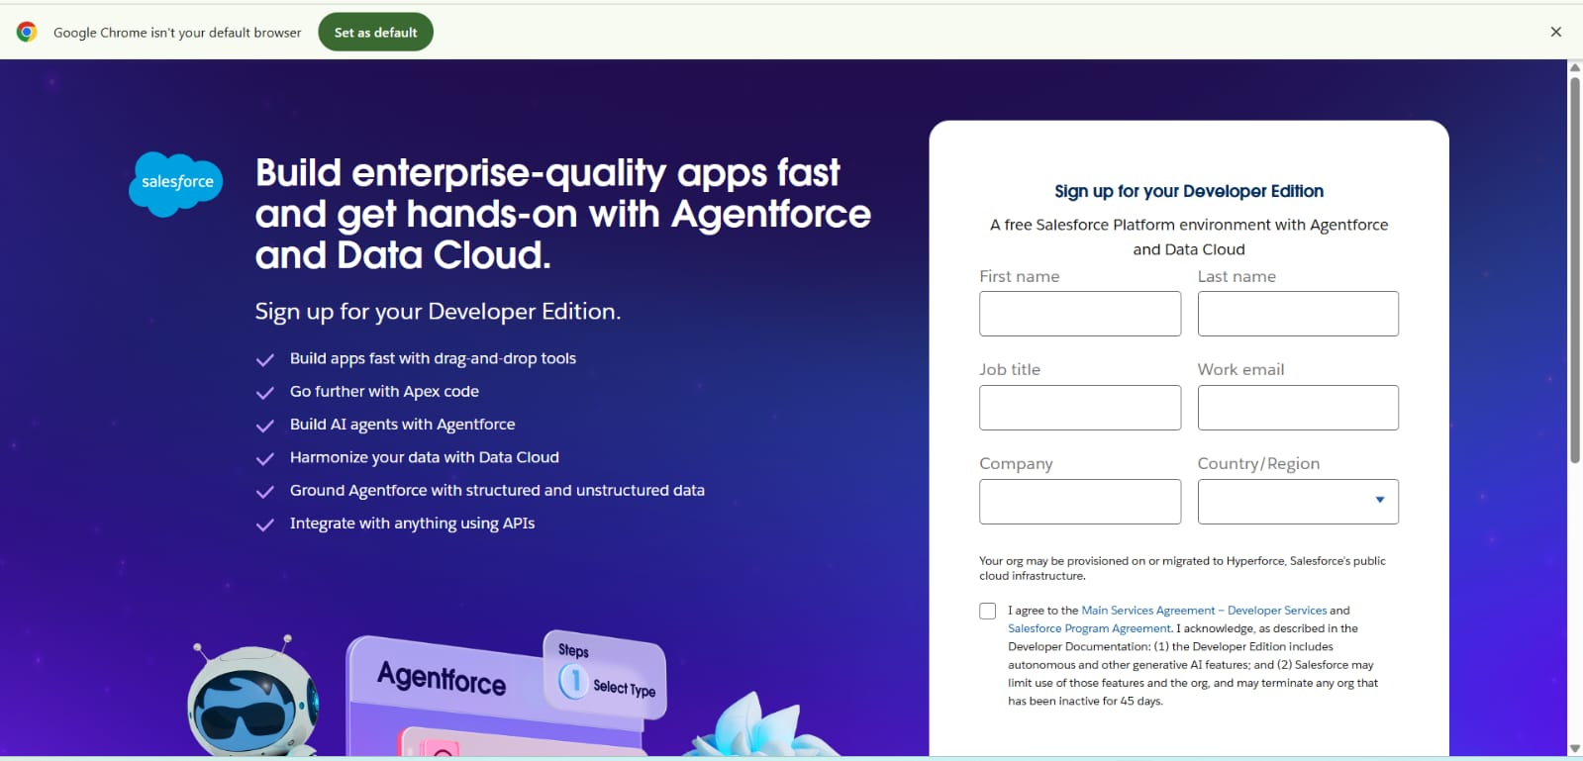

2. On the sign up form, enter the following details :

1. First name & Last name

2. Email

3. Role : Developer

4. Company : College or Company Name

5. County : India

6. Postal Code : pin code

7. Username : should be a combination of your name and company

This need not be an actual email id, you can give anything in the format : username@organization.com Click on sign me up after filling these.

**Activity 2: Account Activation**

1. Go to the inbox of the email that you used while signing up. Click on the verify account to activate your account. The email may take 5-10mins.

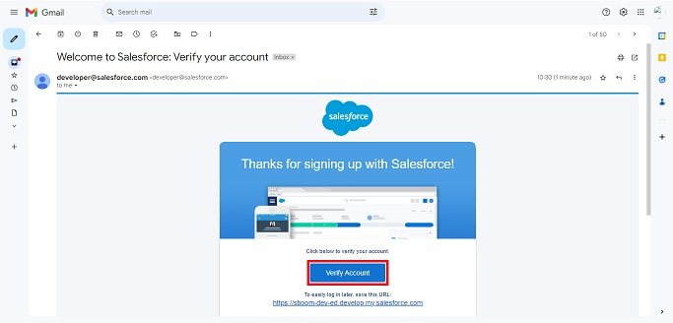

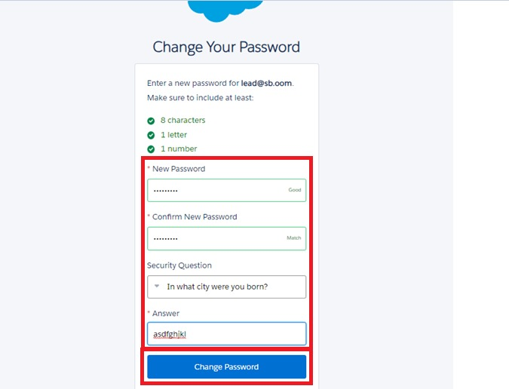

1. Click on Verify Account

2. Give a password and answer a security question and click on change password.

3.Then you will redirect to your salesforce setup page.

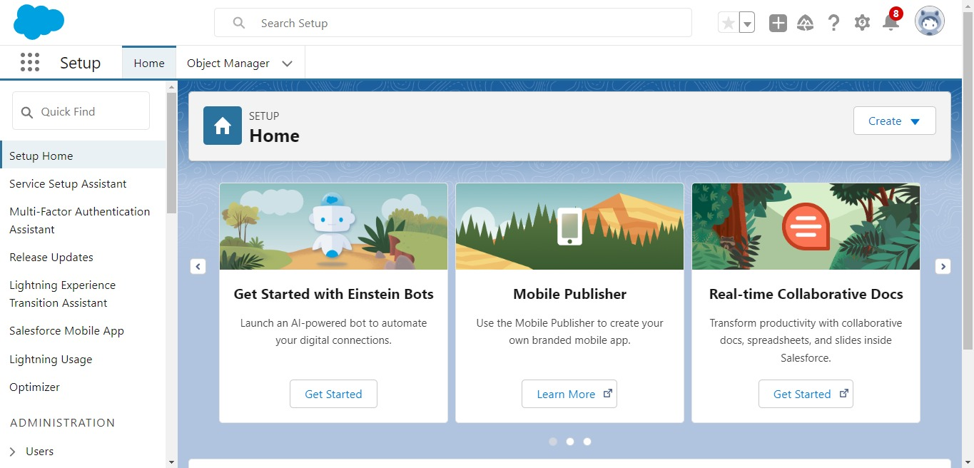

**Milestone 2 :OBJECT :-**

**To Navigate to Setup page:**

Click on gear icon ? click setup.

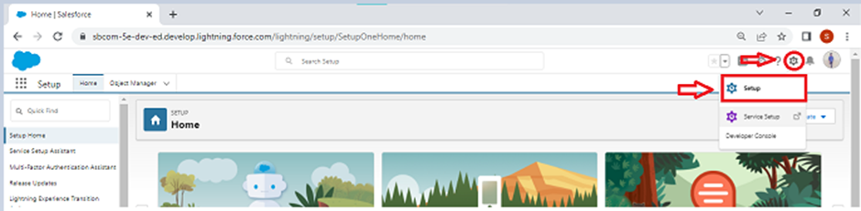

**To create an object:**

1.From the setup page ? Click on Object Manager ? Click on Create ? Click on Custom Object.

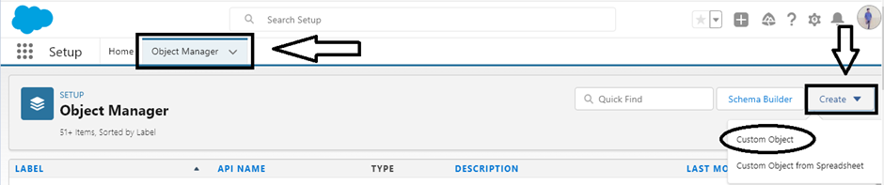

2.On Custom object defining page:

3.Enter the label name, plural label name, click on Allow reports, Allow search.

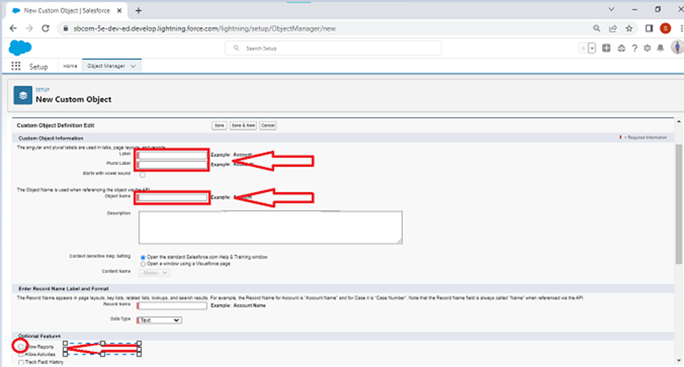

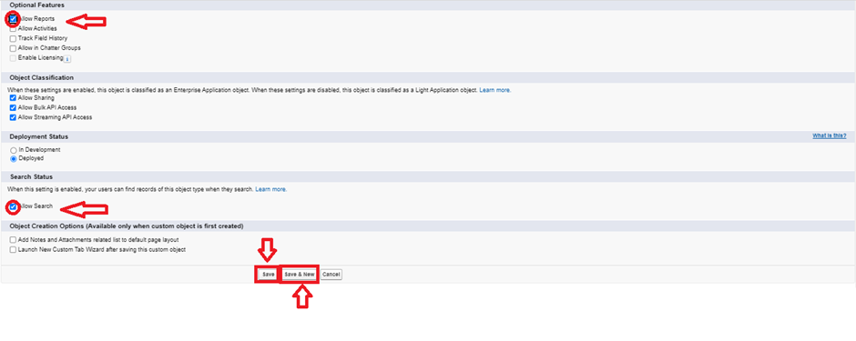

4.Click on Save.

**Create Appointment Object**

To create an object:

1. From the setup page >> Click on Object Manager >> Click on Create >> Click on Custom Object.

* Enter the label name >> Appointment
* Plural label name >> Appointments
* Enter Record Name Label and Format
* Record Name >> Appointment Name
* Data Type >> Auto Number
* Display Format >> app-{000}
* Starting number >> 1

1. Click on Allow reports and Track Field History,
2. Allow search >> Save.

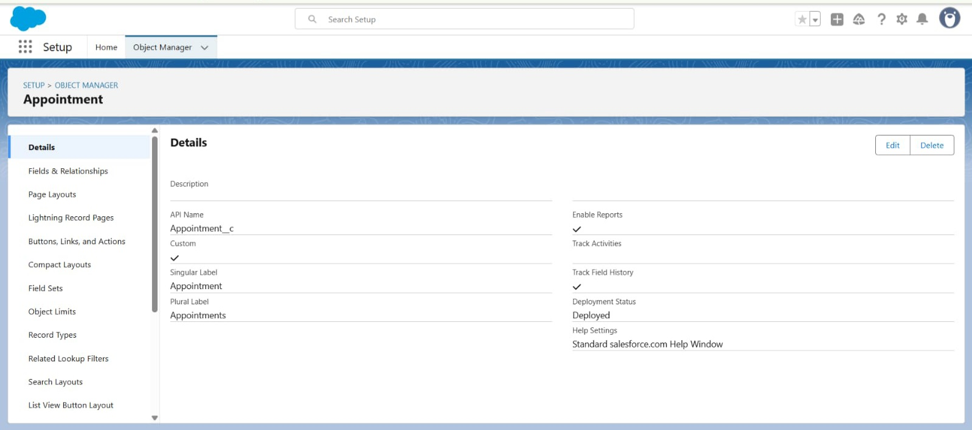6.Allow search >> Save.

**Create Service records Object**

To create an object:

1. From the setup page  >>  Click on Object Manager  >>  Click on Create  >>  Click on Custom Object.

* Enter the label name >> Service records
* Plural label name >> Service records
* Enter Record Name Label and Format
* Record Name >>Service records Name
* Data Type  >>  Auto Number
* Display Format  >> ser-{000}
* Starting number  >>  1

1. Click on Allow reports and Track Field History,
2. Allow search >>  Save

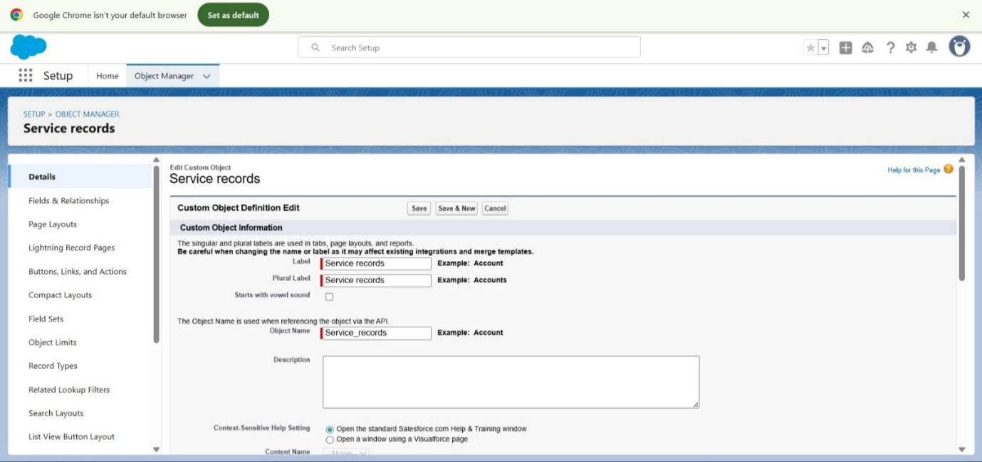

**Create Billing details and feedback Object**

To create an object:

1. From the setup page  >> Click on Object Manager  >> Click on Create  >> Click on Custom Object.

* Enter the label name >> Billing details and feedback
* Plural label name >> Billing details and feedback
* Enter Record Name Label and Format
* Record Name >> Billing details and feedback Name
* Data Type  >> Auto Number
* Display Format  >>  bill-{000}
* Starting number  >> 1

1. Click on Allow reports and Track Field History,
2. Allow search  >>  Save.

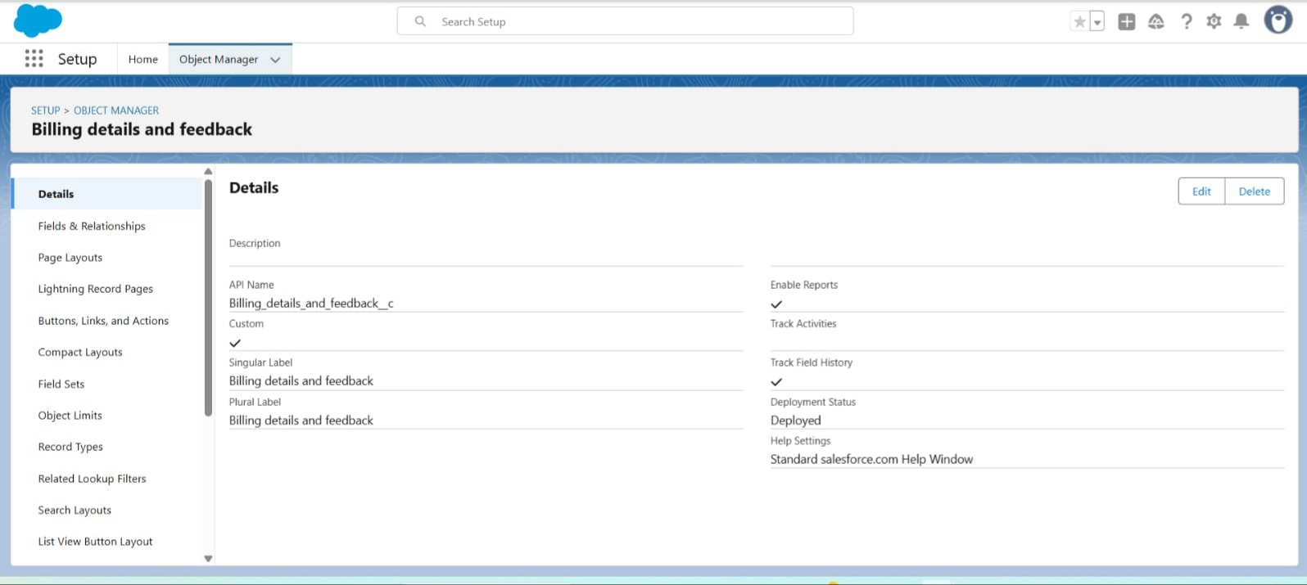

**TABS:**

A **tab** is a user interface element used to view or create records for objects in Salesforce.

**Types of Tabs:**

* **Custom Tabs:** Display data from custom objects, similar to standard tabs like Accounts or Contacts.
* **Web Tabs:** Show external web content or apps within Salesforce.
* **Visualforce Tabs:** Display a Visualforce page within a tab.
* **Lightning Component Tabs:** Add Lightning components to the navigation in Lightning Experience or the mobile app.
* **Lightning Page Tabs:** Let you add Lightning Pages to the mobile app menu. These don't appear on the All Tabs page or in tab customization options.

**Creating a Custom Tab**

To create a Tab:(Customer Details)

1.Go to setup page >> type Tabs in Quick Find bar >> click on tabs >> New (under custom object tab)

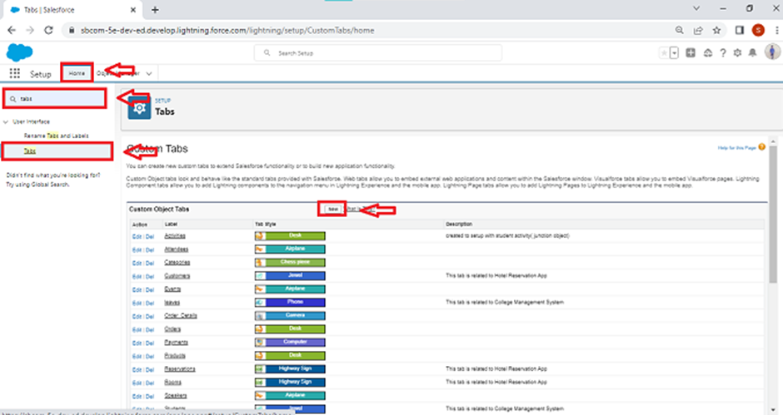

2.Select Object(Customer Details) >> Select the tab style >> Next (Add to profiles page) keep it as default >> Next (Add to Custom App)  uncheck the include tab .

3.Make sure that the Append tab to users' existing personal customizations is checked.

4.Click save.

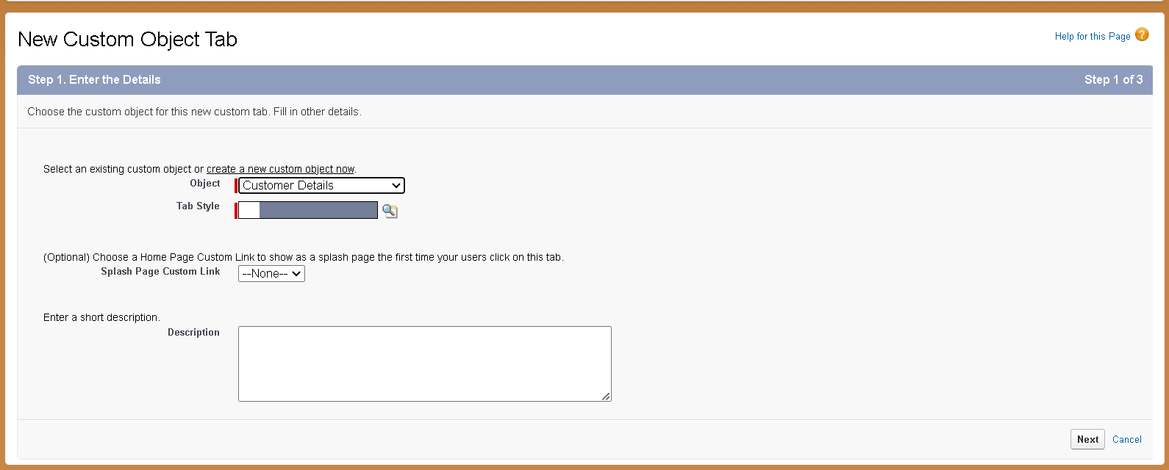

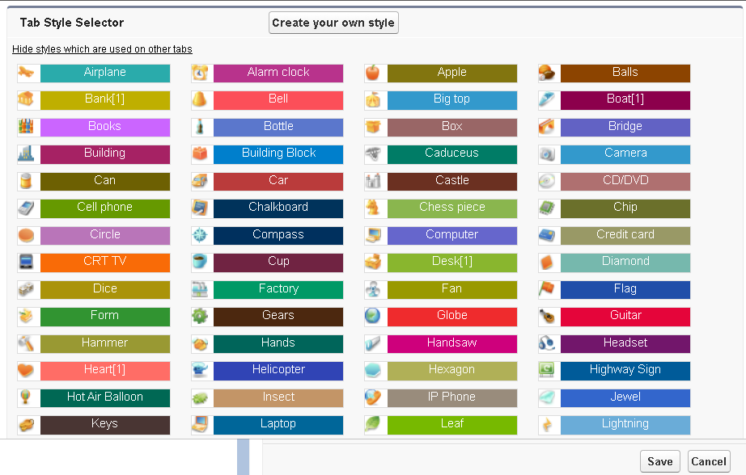

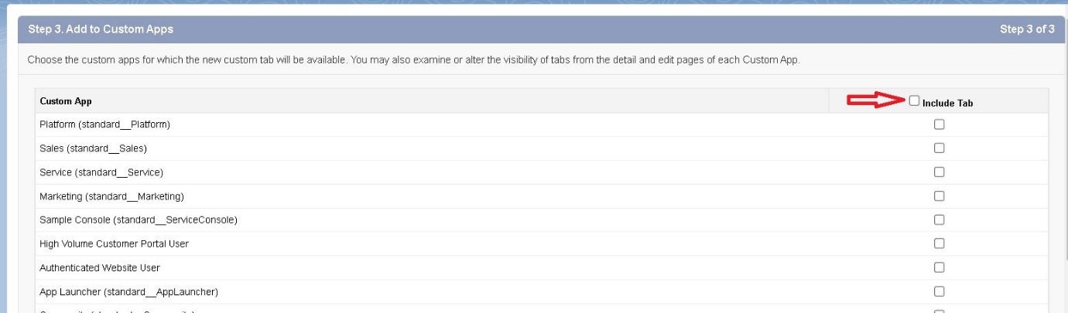

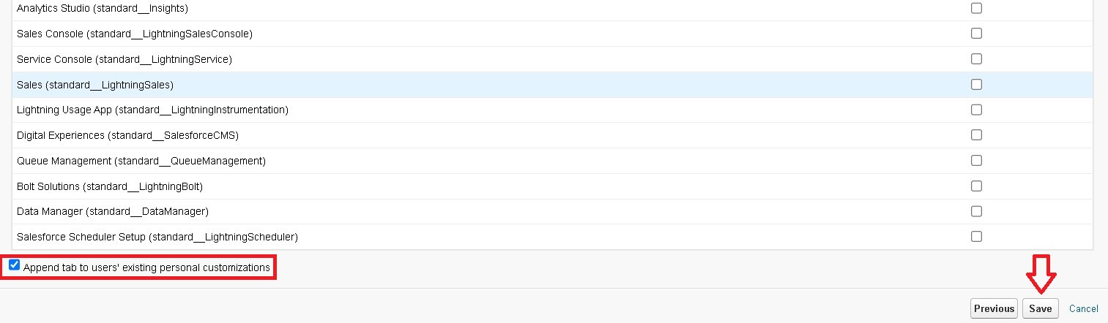

**Creating Remaining Tabs**

1. Now create the Tabs for the remaining Objects, they are “ Appointments, Service records,Billing details and feedback”.
2. Follow the same steps as mentioned in Activity -1 .

**The Lightning App**

A **Lightning App** is a collection of objects, tabs, and tools grouped for a specific function. It provides a customized navigation bar in Lightning Experience, allowing users to work efficiently. Apps can be branded with custom colors, logos, utility bars, and Lightning page tabs.

**Create a Lightning App**

To create a lightning app page:

1. Go to setup page >> search “app manager” in quick find >> select “app manager” >> click on New lightning App.

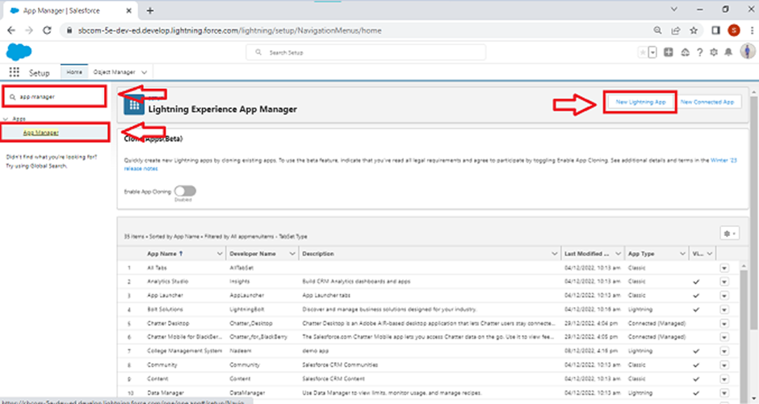

1. **App Details:**
   * Enter app name: **Garage Management Application**
   * Click **Next**
2. **App Options:**
   * Keep default settings
   * Click **Next**
3. **Utility Items:**
   * Keep default settings
   * Click **Next**
4. **Navigation Items:**
   * Search and add:
     + **Customer Details**
     + **Appointments**
     + **Service Record**
     + **Billing Details and Feedback**
     + **Reports and Dashboards**
   * Use the arrow button to move them to the selected list
   * Click **Next**
5. **User Profiles:**
   * Search **System Administrator**
   * Click the arrow button to add
   * Click **Save & Finish**

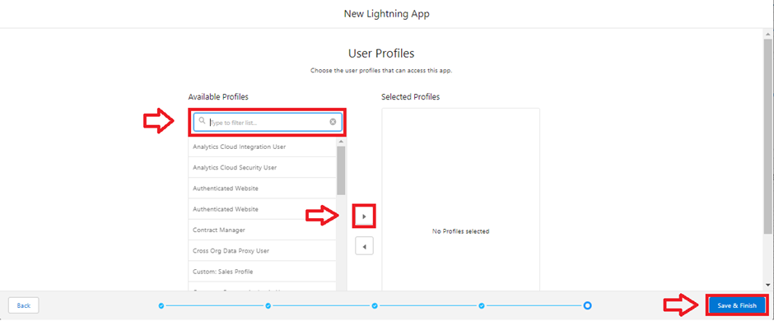

**Creation of fields for the Customer Details object**

1. Go to **Setup**
2. Click **Object Manager**
3. Search for **Customer Details** and click on it
4. Click **Fields & Relationships** → **New**
5. Select **Phone** as Data Type → **Next**
6. Fill:
   * **Field Label:** Phone number
   * **Field Name:** Auto-generated
7. Click **Next** → **Next** → **Save & New**

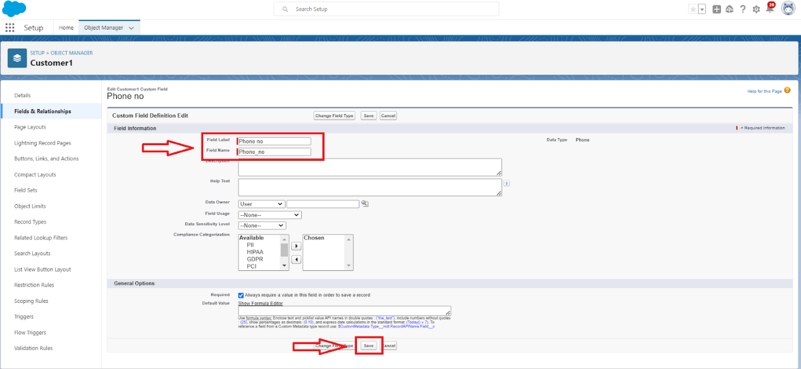

**Steps to Create Another Field in Customer Details:**

1. Go to **Setup**
2. Click **Object Manager**
3. Search **Customer Details** and open it
4. Click **Fields & Relationships** → **New**
5. Select **Email** as Data Type → **Next**
6. Fill:
   * **Field Label:** Gmail
   * **Field Name:** Auto-generated
7. Click **Next** → **Next** → **Save & New**

**Creation of Lookup Fields**

**Creation of Lookup Field on Appointment Object :**

1. Go to **Setup**
2. Click **Object Manager**
3. Search **Appointment** and open it
4. Click **Fields & Relationships** → **New**
5. Select **Lookup Relationship** → **Next**
6. Choose **Customer Details** as the related object → **Next**
7. Click **Next** → **Next** → **Save**

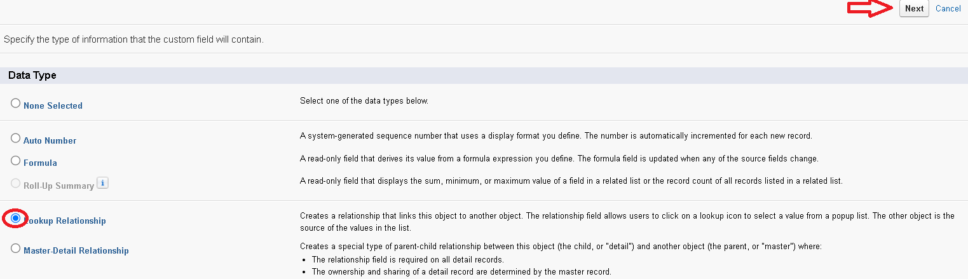

**Creation of Lookup Field on Service records Object :**

1. Go to **Setup**
2. Click **Object Manager**
3. Search **Service Records** and open it
4. Click **Fields & Relationships** → **New**
5. Select **Lookup Relationship** → **Next**
6. Choose **Appointment** as the related object → **Next**
7. **Make it Required** by checking the **Required** box
8. Scroll to **Lookup Filter** → Click **Show Filter Settings**
   * **Field:** Appointment: Appointment Date
   * **Operator:** Less than
   * **Select Field:** Appointment: Created Date
   * **Filter Type:** Required
   * **Error Message:** *Value does not match the criteria.*
   * Check **Active** to enable the filter
9. Click **Next** → **Next** → **Save**

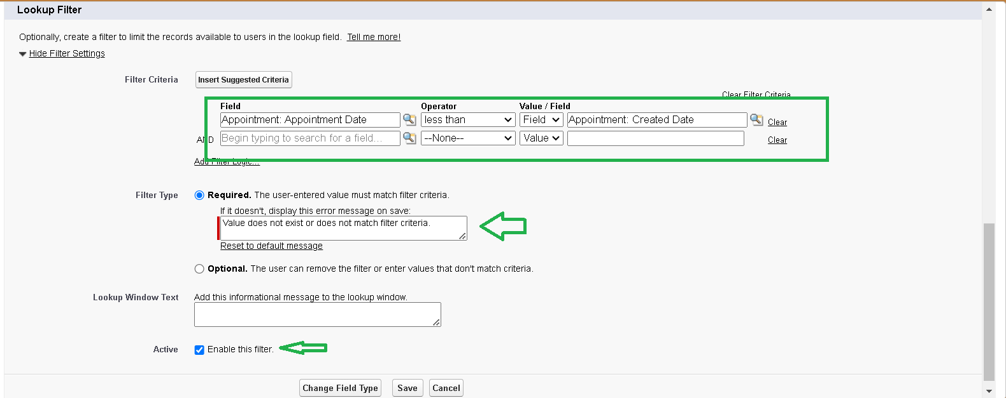

**Creation of Lookup Field on Billing details and feedback Object :**

1. Go to **Setup**
2. Click **Object Manager**
3. Search **Billing Details and Feedback** and open it
4. Click **Fields & Relationships** → **New**
5. Select **Lookup Relationship** → **Next**
6. Choose **Service Records** as the related object → **Next**
7. Click **Next** → **Next** → **Save & New**

**Creation of Checkbox Fields**

**Creation of Checkbox Field  on Appointment Object :**

1. Go to **Setup**
2. Click **Object Manager**
3. Search **Appointment** and open it
4. Click **Fields & Relationships** → **New**
5. Select **Checkbox** → **Next**
6. Fill:
   * **Field Label:** Maintenance service
   * **Field Name:** Auto-populated
   * **Default Value:** Unchecked
7. Click **Next** → **Next** → **Save**

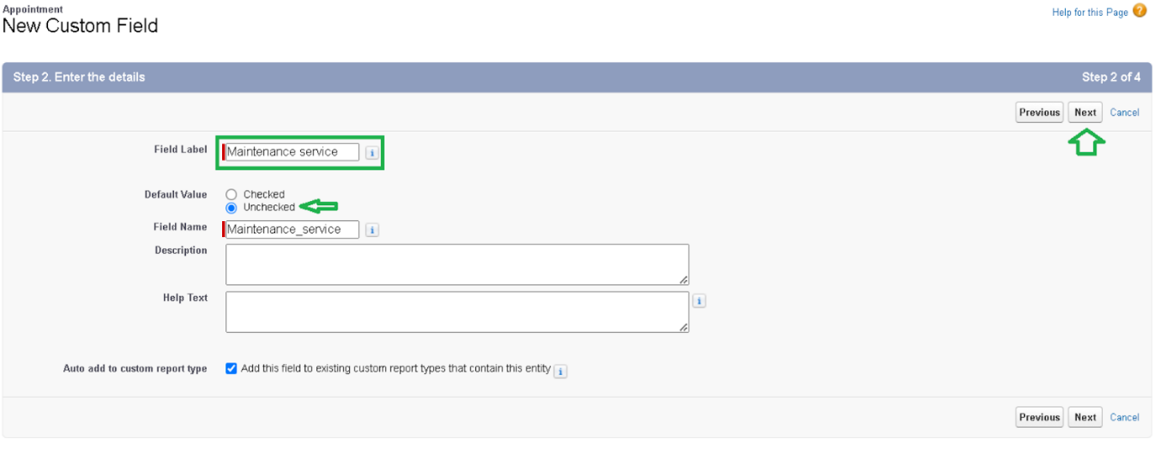

**Creation of Another Checkbox Field  on Appointment Object :**

1. Repeat steps 1 to 3 (Go to Setup → Object Manager → Appointment → Fields & Relationships → New)
2. For **Repairs**:
   * **Field Label:** Repairs
   * **Field Name:** Auto-populated
   * **Default Value:** Unchecked
   * Click **Next** → **Next** → **Save**
3. Repeat steps 1 to 3 again
4. For **Replacement Parts**:
   * **Field Label:** Replacement Parts
   * **Field Name:** Auto-populated
   * **Default Value:** Unchecked
   * Click **Next** → **Next** → **Save**

**Creation of Checkbox Field on Service records Object :**

1. Go to **Setup**
2. Click **Object Manager**
3. Search **Service Records** and open it
4. Click **Fields & Relationships** → **New**
5. Select **Checkbox** → **Next**
6. Fill:
   * **Field Label:** Quality Check Status
   * **Field Name:** Auto-populated
   * **Default Value:** Unchecked
7. Click **Next** → **Next** → **Save**

**Creation of date Fields**

**Creation of Date Field on Appointment Object :**

1. Go to **Setup**
2. Click **Object Manager**
3. Search **Appointment** and open it
4. Click **Fields & Relationships** → **New**
5. Select **Date** → **Next**
6. Fill:
   * **Field Label:** Appointment Date
   * **Field Name:** Auto-populated
   * Check **Required**
7. Click **Next** → **Next** → **Save**

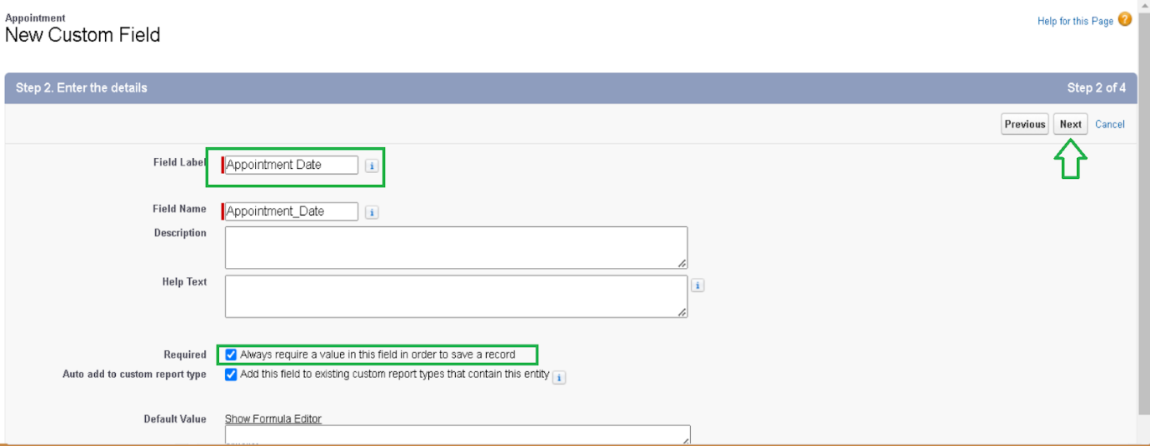

**Creation of Currency Fields**

**Creation of Currency Field on Appointment Object :**

1. Go to **Setup**
2. Click **Object Manager**
3. Search **Appointment** and open it
4. Click **Fields & Relationships** → **New**
5. Select **Currency** → **Next**
6. Fill:
   * **Field Label:** Service Amount
   * **Field Name:** Auto-populated
7. Click **Next**
8. Set **Field-Level Security** to **Read-Only** for all profiles

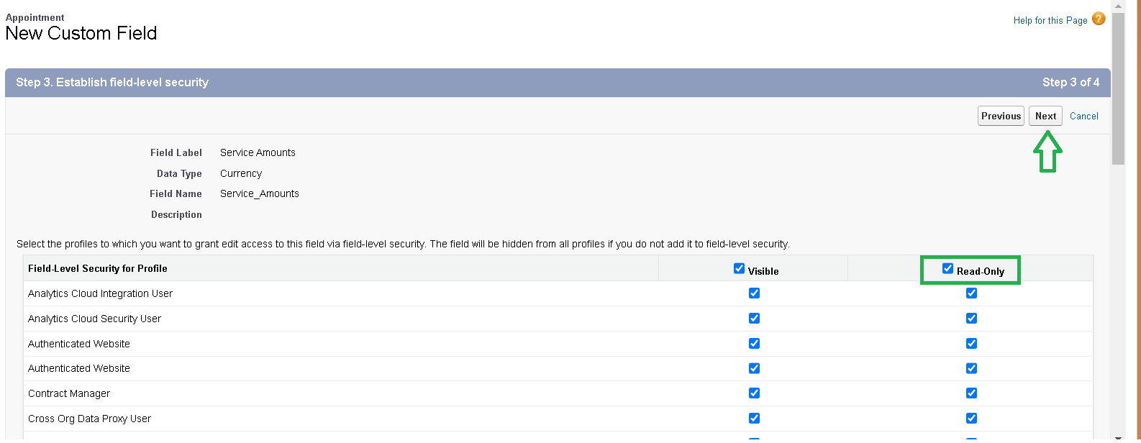

**Creation of Currency Field on Billing details and feedback Object :**

1. Go to **Setup**
2. Click **Object Manager**
3. Search **Billing Details and Feedback** and open it
4. Click **Fields & Relationships** → **New**
5. Select **Currency** → **Next**
6. Fill:
   * **Field Label:** Payment Paid
   * **Field Name:** Auto-populated
7. Click **Next**
8. Set **Field-Level Security** to **Read-Only** for all profiles
9. Click **Next** → **Save**

**Creation of Text Fields**

1. Go to **Setup**
2. Click **Object Manager**
3. Search **Appointment** and open it
4. Click **Fields & Relationships** → **New**
5. Select **Text** → **Next**
6. Fill:
   * **Field Label:** Vehicle number plate
   * **Field Name:** Auto-populated
   * **Length:** 10
   * Check **Required** and **Unique**
7. Click **Next** → **Next** → **Save**

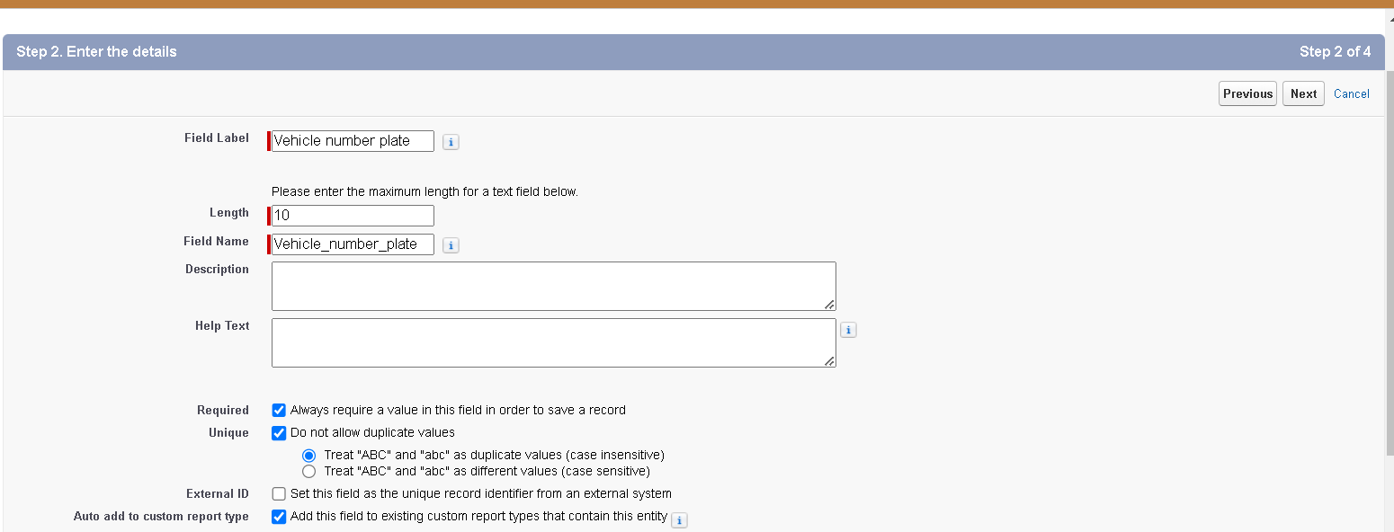

**Creation of Text Fields in Billing details and feedback object :**

1. Go to **Setup**
2. Click **Object Manager**
3. Search **Billing Details and Feedback** and open it
4. Click **Fields & Relationships** → **New**
5. Select **Text** → **Next**
6. Fill:
   * **Field Label:** Rating for service
   * **Field Name:** Auto-populated
   * **Length:** 1
   * Check **Required**
7. Click **Next** → **Next** → **Save**

**Creation of Picklist Fields**

**Creation of Picklist Fields in Service records object :**

1. Go to **Setup**
2. Click **Object Manager**
3. Search **Service Records** and open it
4. Click **Fields & Relationships** → **New**
5. Select **Picklist** → **Next**
6. Fill:
   * **Field Label:** Service Status
   * Choose **Enter values, with each value separated by a new line**
   * Enter values:
7. Click **Next** → **Next** → **Save**

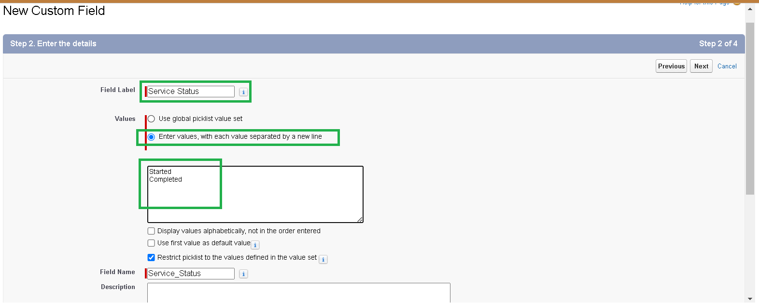

**Creation of Picklist Fields in Billing details and feedback object :**

1. Go to Setup
2. Open Object Manager
3. Find and select **Billing Details and Feedback**
4. Click on **Fields & Relationships**, then **New**
5. Choose **Picklist** and click Next
6. Enter **Payment Status** as the Field Label
7. Choose to enter values manually, and add:
   * Pending
   * Completed
8. Click Next, Next, then Save

**Creating Formula Field in Service records Object**

1. Go to **Setup**
2. Click **Object Manager**
3. Search and select **Service Records**
4. Go to **Fields & Relationships** → **New**
5. Select **Formula** → **Next**
6. Enter **Field Label** and **Field Name** as **service date**
7. Choose **Formula Return Type** as **Date** → Click **Next**
8. In the formula editor, insert **CreatedDate**
9. Click **Check Syntax**
10. Click **Next** → **Next** → **Save**

**To create a validation rule to an Appointment Object**

1. Go to the setup page >>  click on object manager  >>  From drop down click edit for  Appointment object.
2. Click on the validation rule  >> click New.

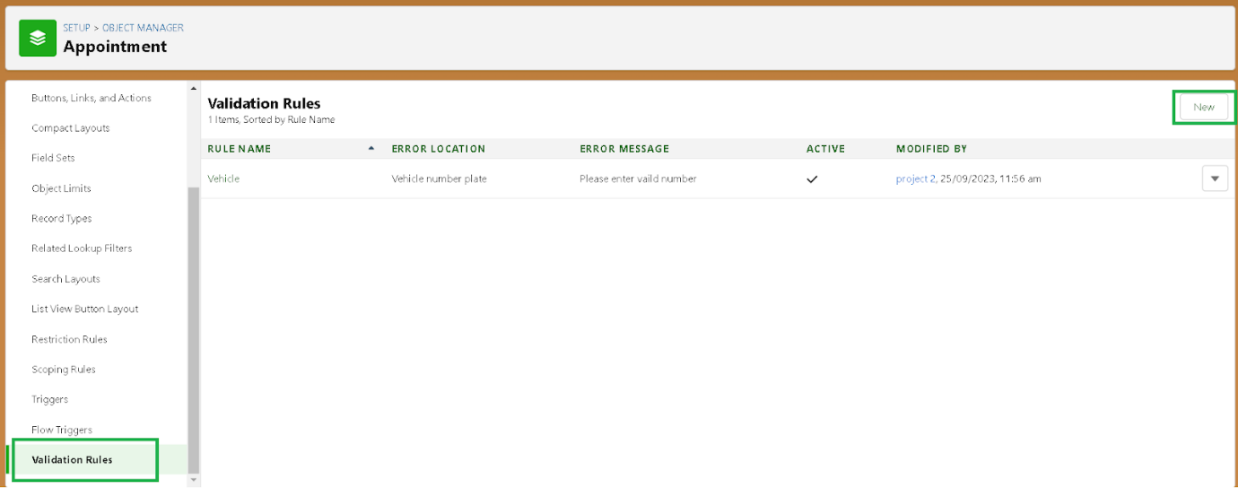

1. Enter the Rule name as “ Vehicle ”.
2. Insert the Error Condition Formula as : -

NOT(REGEX( Vehicle_number_plate__c , "[A-Z]{2}[0-9]{2}[A-Z]{2}[0-9]{4}"))

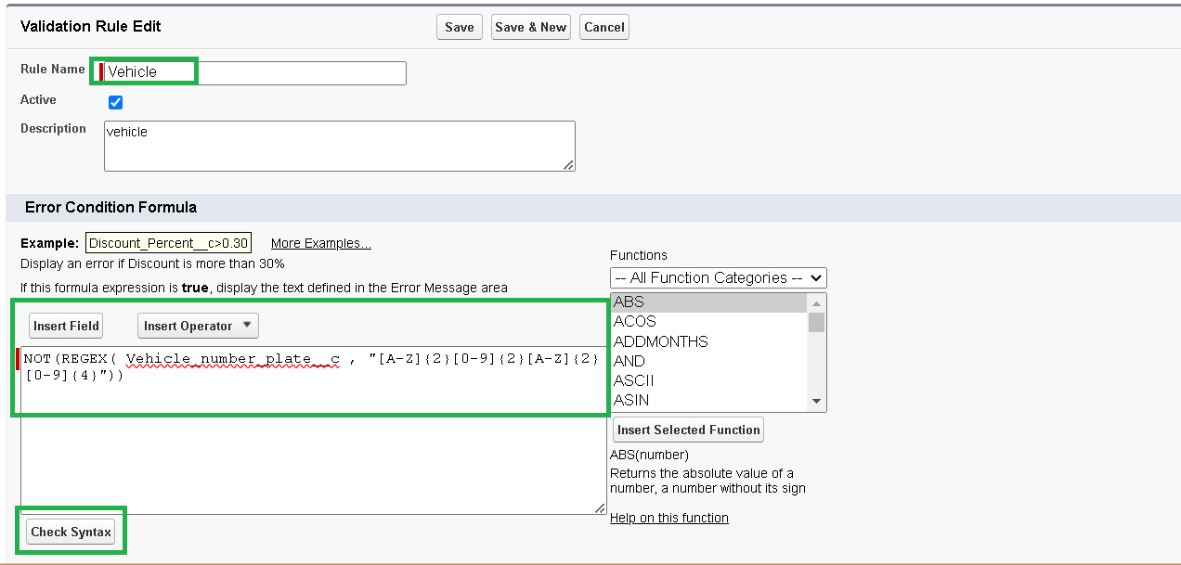

5.Enter the Error Message as “Please enter vaildnumber ”, select the Error location as Field and select the field as “Vehicle number plate”, and click Save.

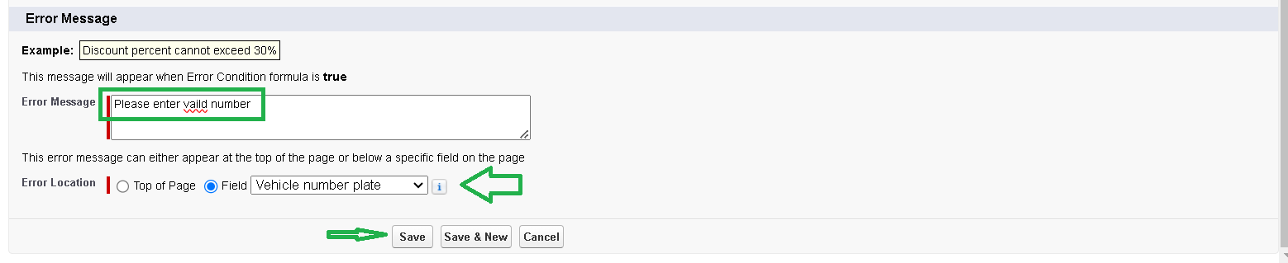

**To create a validation rule to an Billing details and feedback Object**

1. Go to **Setup**
2. Click **Object Manager**
3. Find and open **Billing Details and Feedback**
4. Click **Validation Rules** → **New**
5. **Rule Name:** rating_should_be_less_than_5
6. In the formula area, add the logic to check if rating is between 1 and 5
7. **Error Message:** rating should be from 1 to 5
8. **Error Location:** Choose **Field** → Select **Rating for Service**
9. Click **Save**

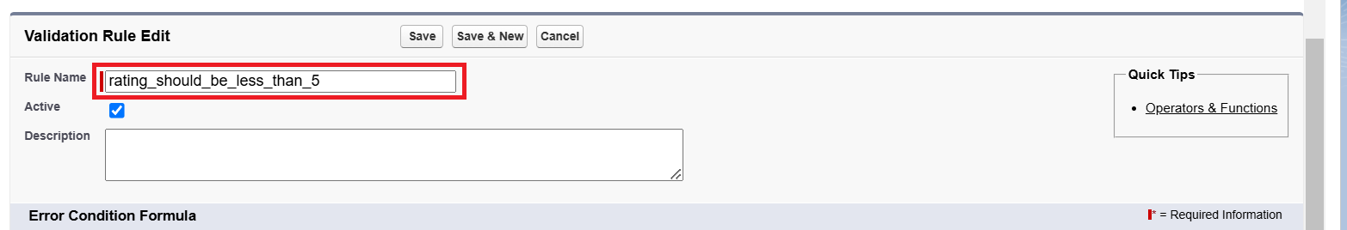

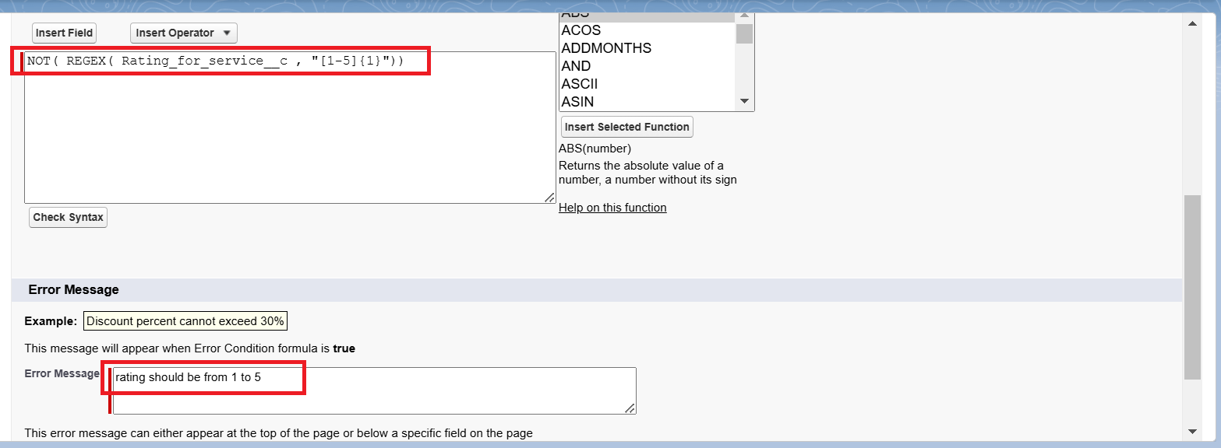

**To create a matching rule to an Customer details Object**

1. Go to **Setup**
2. In the **Quick Find** box, search for **Matching Rule**

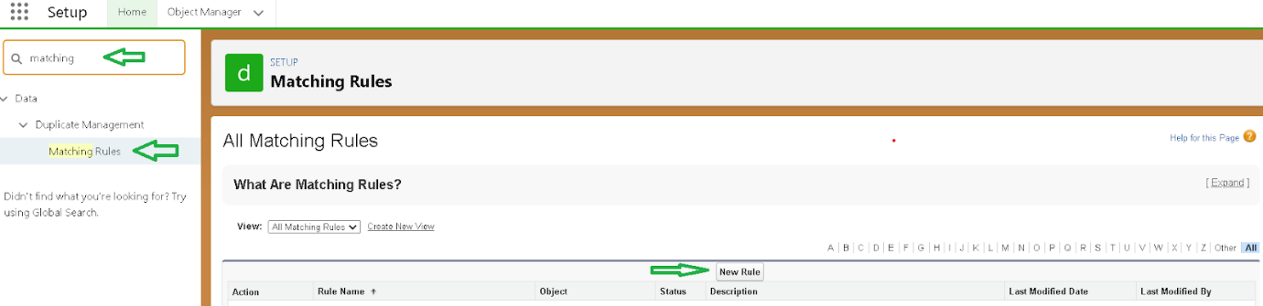

1. Click **Matching Rules** → **New Rule**

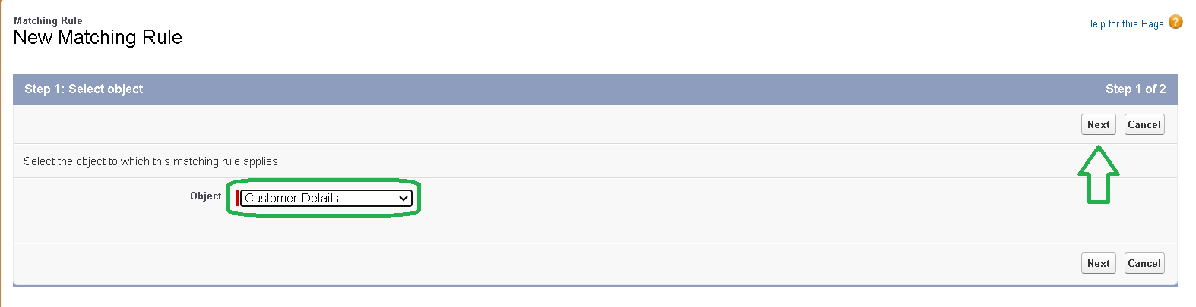

1. Select **Customer Details** as the object → Click **Next**
2. Enter **Rule Name:** Matching customer details
   * **Unique Name:** Auto-filled
3. Define Matching Criteria:
   * **Gmail** → **Matching Method:** Exact
   * **Phone Number** → **Matching Method:** Exact
4. Click **Save**
5. After saving, click **Activate**

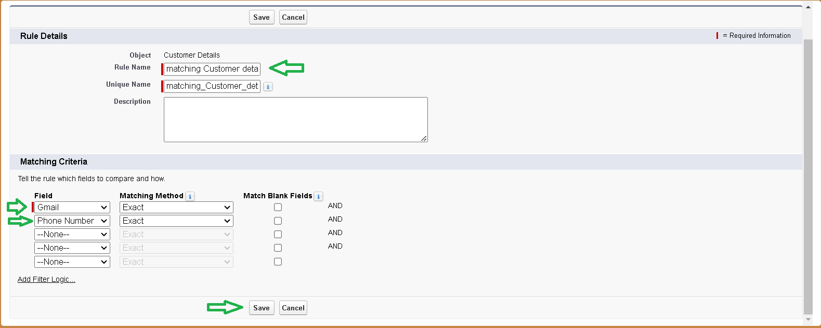

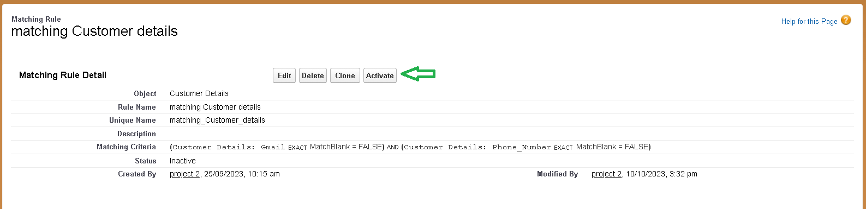

**To create a Duplicate rule to an Customer details Object**

1. Go to **Setup**
2. In the **Quick Find** box, search for **Duplicate Rules**

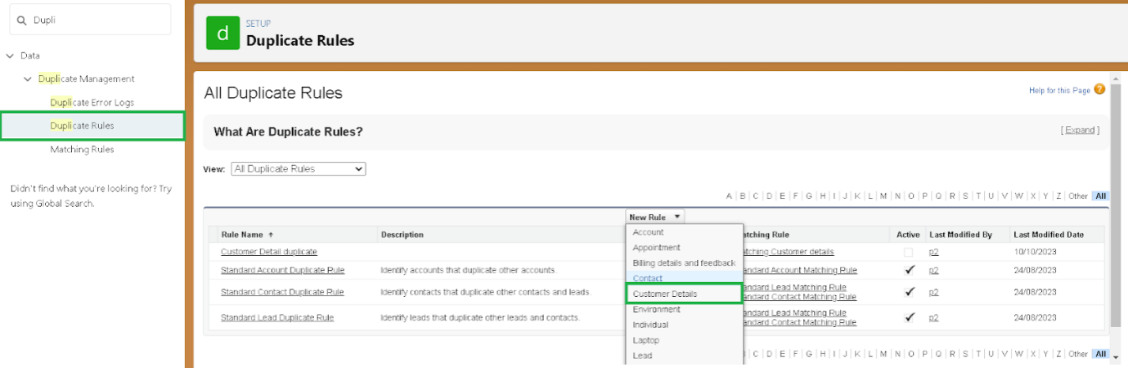

1. Click **Duplicate Rules** → **New Rule**
2. Select **Customer Details** as the object
3. Enter **Rule Name:** Customer Detail duplicate
4. Scroll to the **Matching Rule** section
5. Select **Matching customer details**

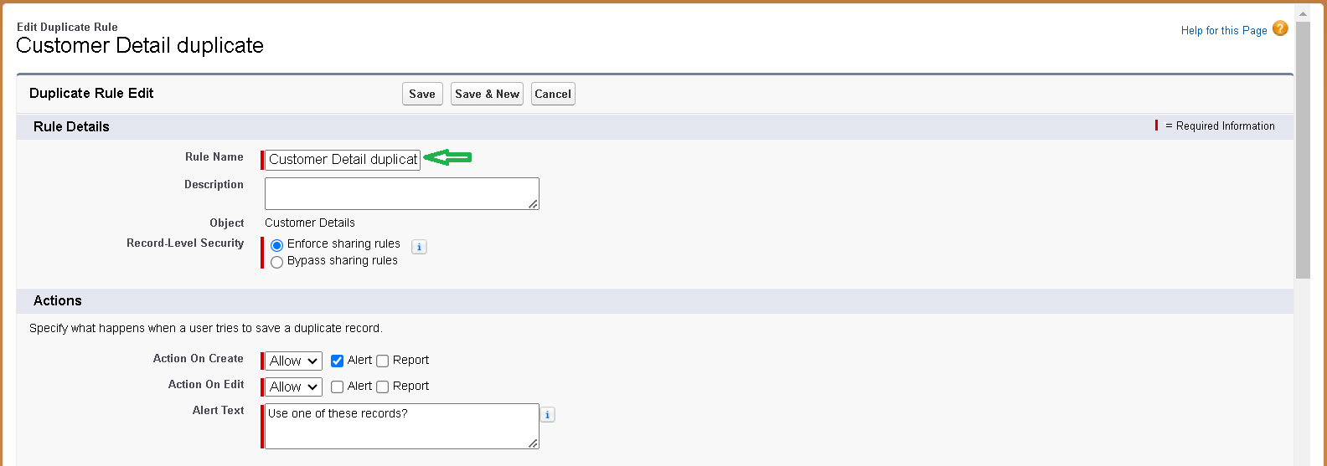

1. Click **Save**
2. After saving, click **Activate**

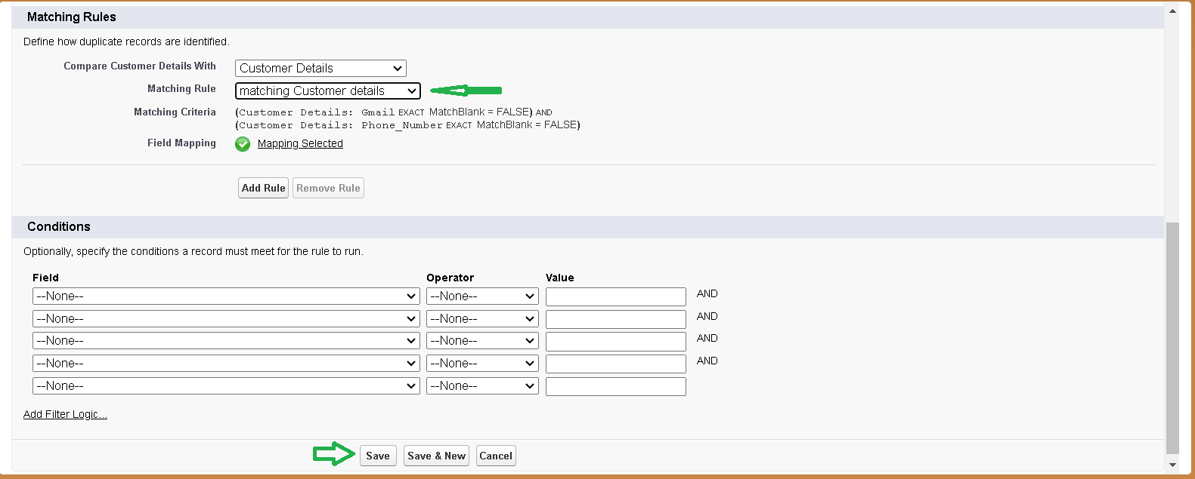

**Manager Profile**

**To create a new profile:**

1.Go to setup >>  type profiles in quick find box  >>  click on profiles  >>  clone the desired profile (Standard User)  >>  enter profile name (Manager)  >>  Save.

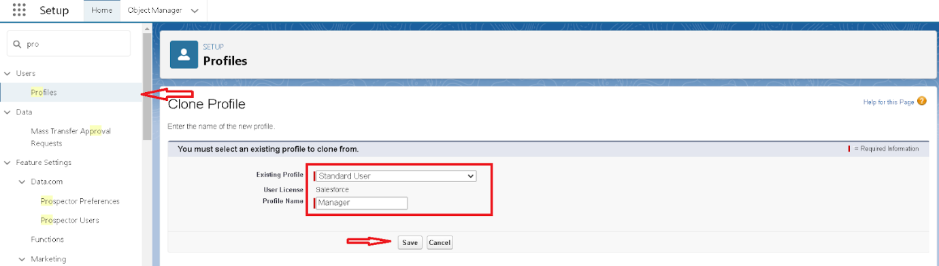

2.While still on the profile page, then click Edit.

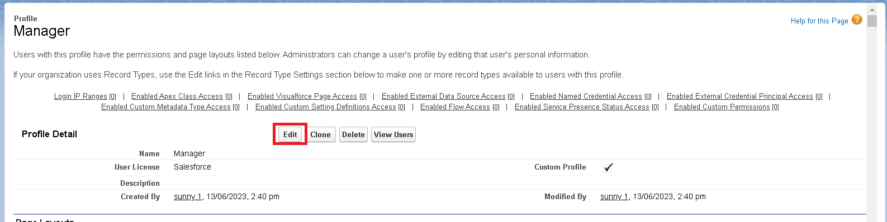

3.Select the Custom App settings as default for the Garage management.

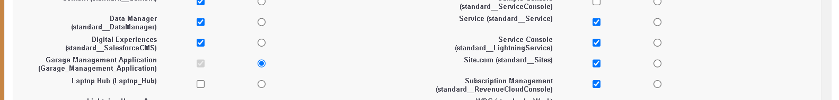

4.Scroll down to Custom Object Permissions and Give access permissions for Appointments,Billing details and feedback , service records and customer details objects as mentioned in the below diagram.

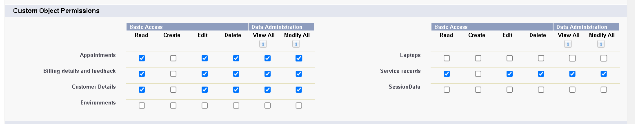

5.Changing the session times out after should be “ 8 hours of inactivity”.

6.Change the password policies as mentioned :

7.User passwords expire in should be “ neverexpires ”.

8.Minimum password length should be “ 8 ”, and click save.

**Sales person Profile**

1. Go to **Setup**
2. In the **Quick Find** box, type **Profiles**
3. Click on **Profiles**
4. Find and **clone** the profile **Salesforce Platform User**
5. Enter **Profile Name:** sales person → Click **Save**
6. On the profile page, click **Edit**
7. Set **Garage Management Application** as the **default app**
8. Scroll to **Custom Object Permissions**
9. Give required access to:
   * Appointments
   * Billing details and feedback
   * Service records
   * Customer details

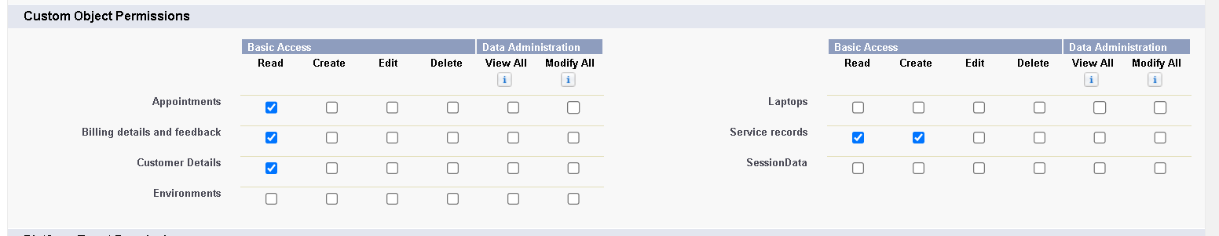

**Creating Manager Role**

1. Go to **Setup**
2. In the **Quick Find** box, search for **Roles**

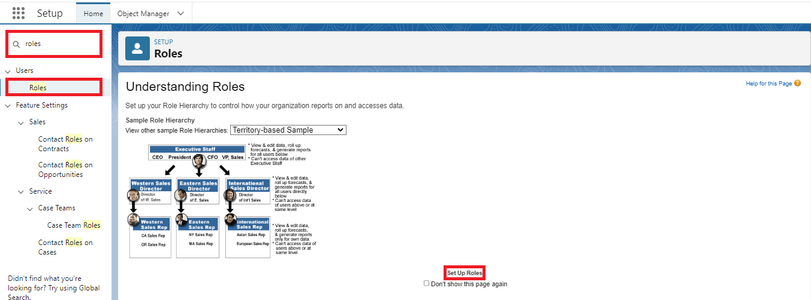

1. Click on **Set Up Roles**

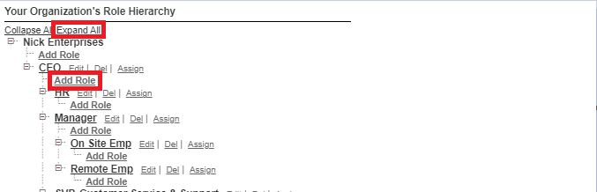

1. Click **Expand All**
2. Click **Add Role** under the role this new role reports to
3. Enter **Label:** Manager (Role Name auto-fills)
4. Click **Save**

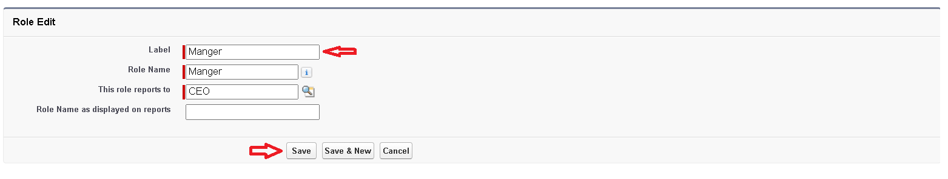

**Creating another roles**

1. Go to **Setup**
2. In the **Quick Find** box, type **Roles**
3. Click **Set Up Roles**
4. Click the **plus (+)** next to **CEO** to expand
5. Click **Add Role** under **Manager**

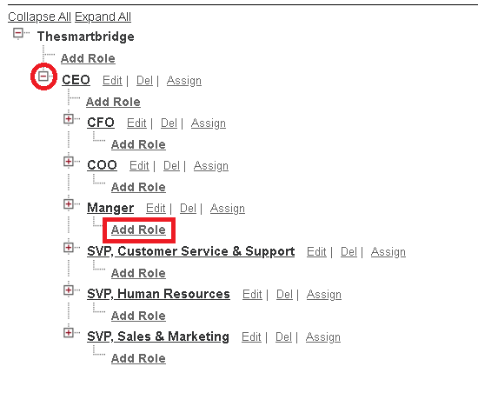

1. Enter **Label:** sales person (Role Name auto-fills)
2. Click **Save**

**Create User**

1. Go to **Setup**
2. In the **Quick Find** box, type **Users**
3. Click **Users**
4. Click **New User**
5. Fill in the details:
   * **First Name:** Niklaus
   * **Last Name:** Mikaelson
   * **Alias:** (your chosen alias)
   * **Email:** (your personal email)
   * **Username:** (format: text@text.text)
   * **Nickname:** (your chosen nickname)
   * **Role:** Manager
   * **User License:** Salesforce
   * **Profile:** Manager
6. Click **Save**

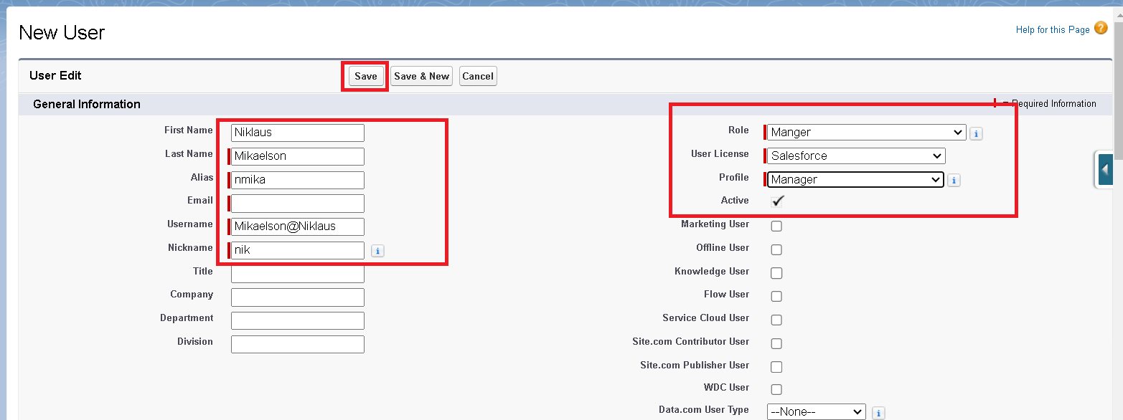

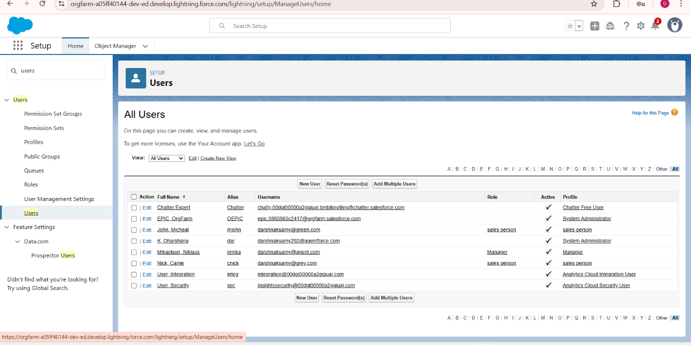

**creating another users**

1. Repeat the steps to create a new user
2. Fill in the details as before, but change these:
   * **Role:** sales person
   * **User License:** Salesforce Platform
   * **Profile:** sales person
3. Complete other fields as needed
4. Click **Save**

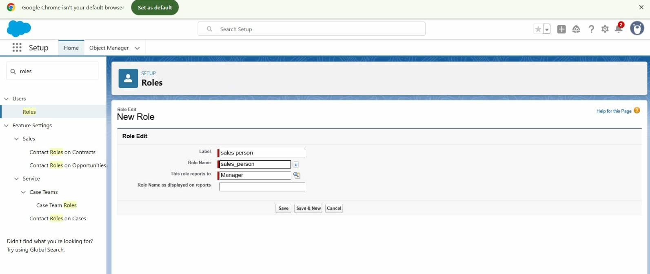

**Creating New Public Group**

1. Go to **Setup**
2. In the **Quick Find** box, type **Public Groups**

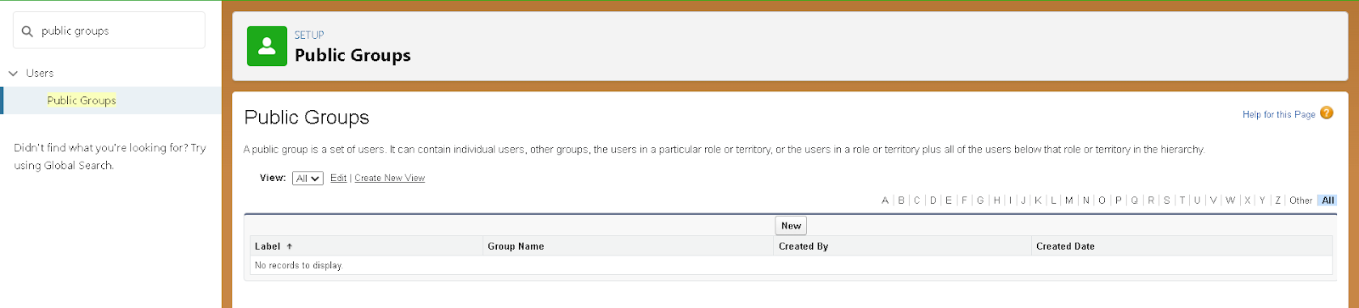

1. Click **Public Groups** → **New**
2. Enter **Label:** sales team (Group Name auto-fills)
3. Search for **Roles**
4. In **Available Members**, select **Sales person**
5. Click **Add** to move it to **Selected Members**
6. Click **Save**

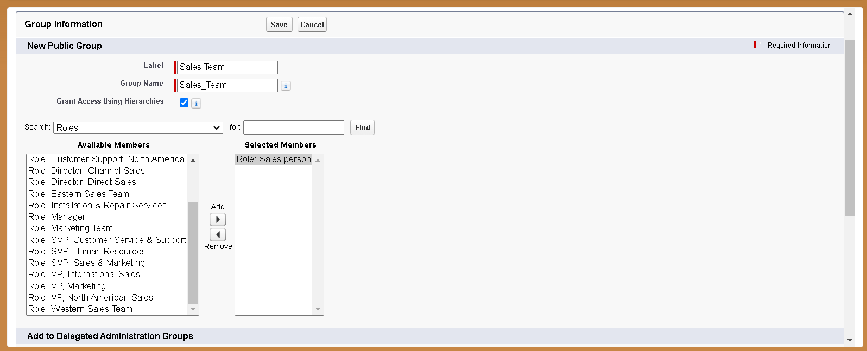

**Creating Sharing settings**

1. Go to **Setup**
2. In **Quick Find**, type **Sharing Settings**
3. Click **Sharing Settings** → Click **Edit**
4. Change **Organization-Wide Default (OWD)** for **Service Records** to **Private**

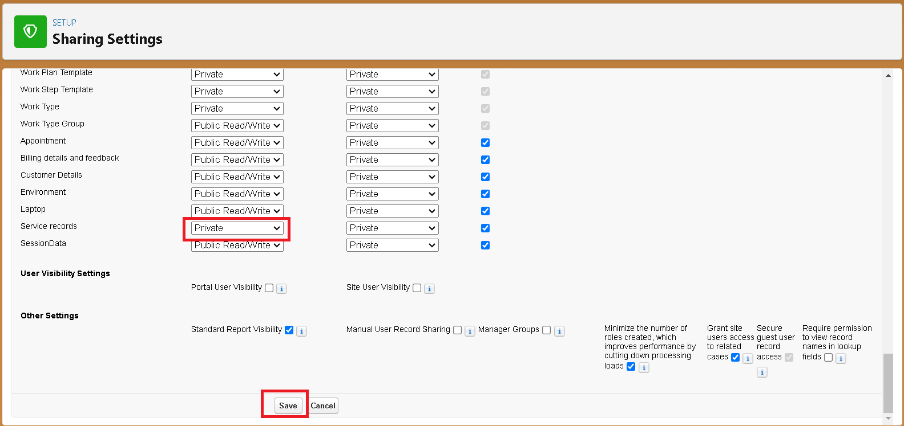

1. Click **Save** and **Refresh**
2. Scroll down to **Service Records Sharing Rules** → Click **New**



1. Enter **Label:** Sharing setting (Rule Name auto-fills)
2. In **Step 3:** Select records owned by **Roles** → choose **Sales person**
3. In **Step 4:** Share with **Roles** → choose **Manager**
4. In **Step 5:** Set access level to **Read/Write**
5. Click **Save**

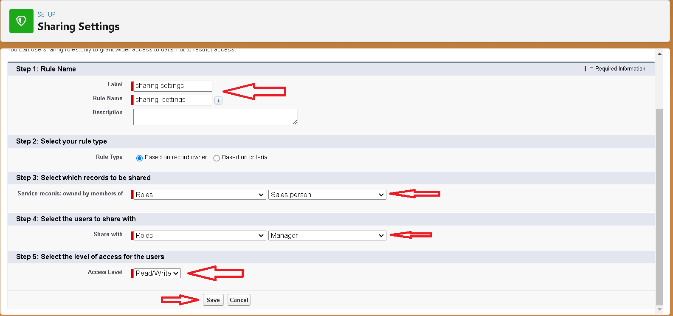

**Create a Flow**

1. Go to setup and type **Flow** in the quick find box, then click on **Flows** and select **New Flow**.

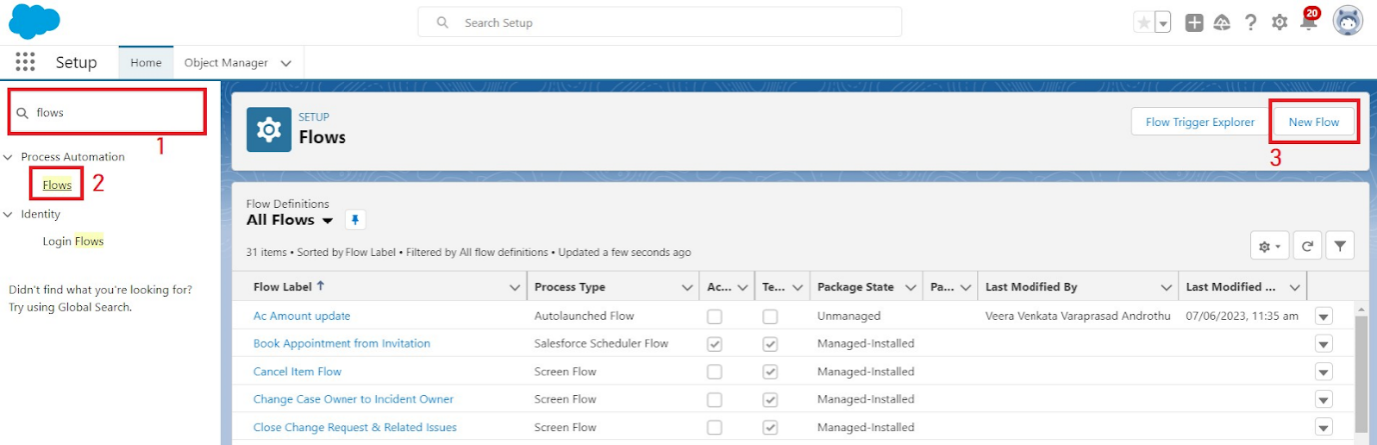

1. Choose **Record-triggered flow** and click **Create**

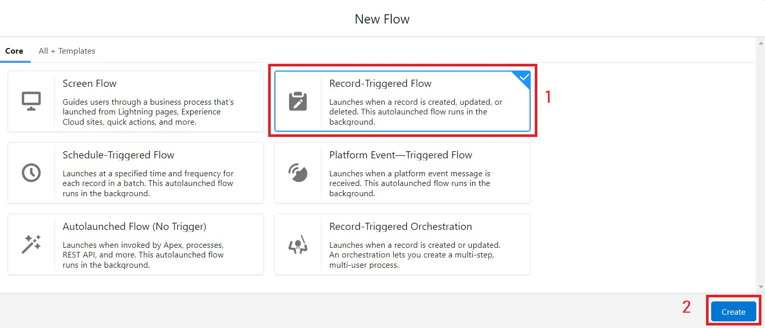

1. Select the object as **Billing details and feedback** from the drop-down list.
2. Set the trigger to run when **A record is Created or Updated**.
3. Optimize the flow for **Actions and Related Records** and click **Done**.

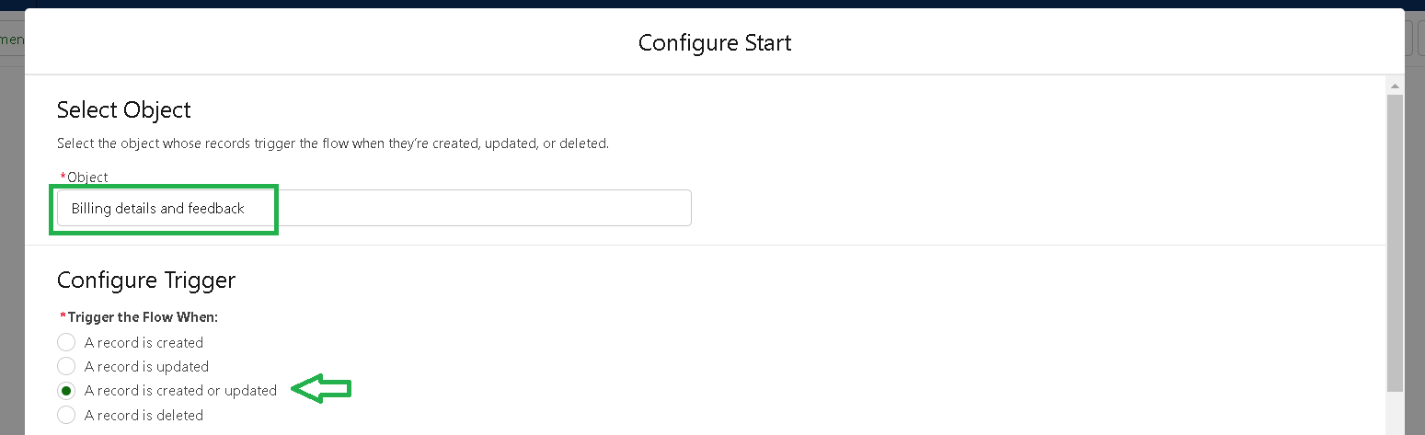

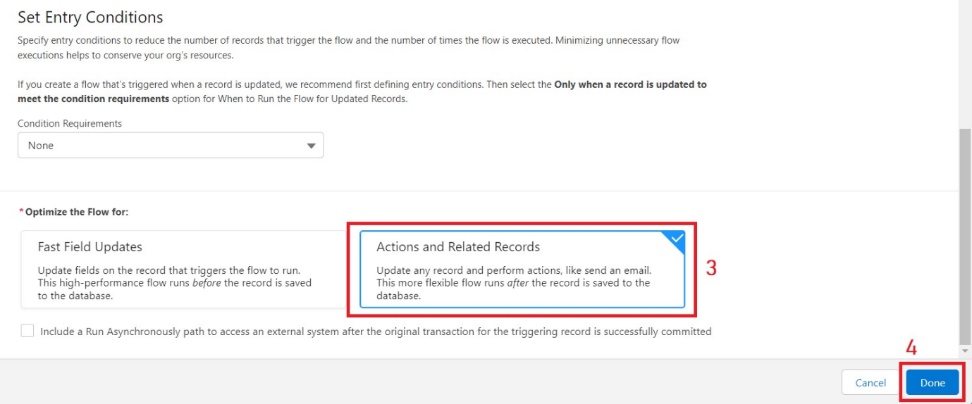

1. Under the Record-triggered Flow, click the **+** symbol and select **Update Records**.

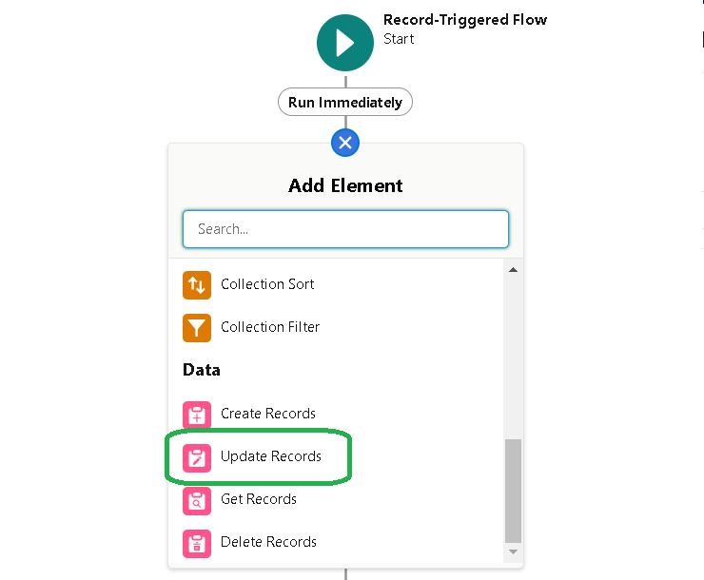

1. Give the label name **Amount Update** (API name auto-fills).

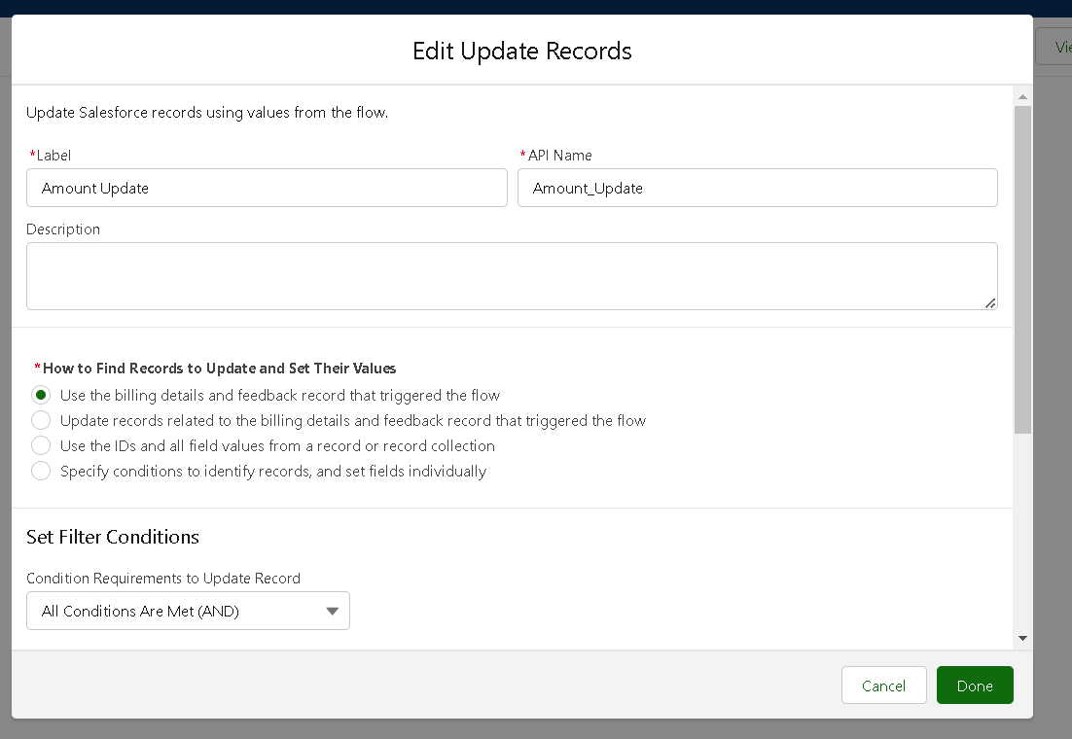

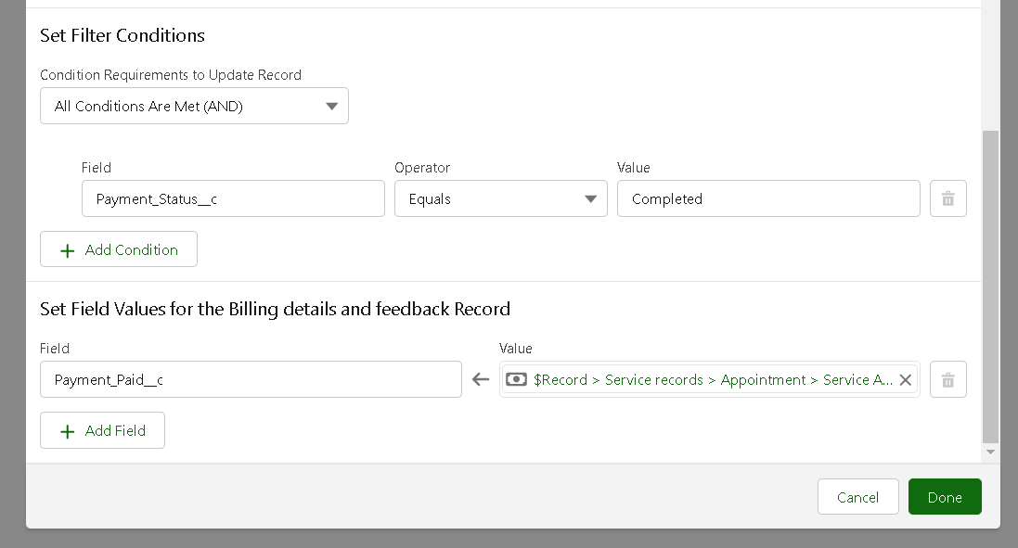

1. Set the filter condition as **All Conditions are met (AND)**, with field **Payment_Status__c** equals **Completed**.
2. Set the field value for **Payment_Paid__c** to **{!$Record.Service_records__r.Appointment__r.Service_Amount__c}**.
3. Click **Done**.
4. From the toolbox on the top left, click **New Resource**.

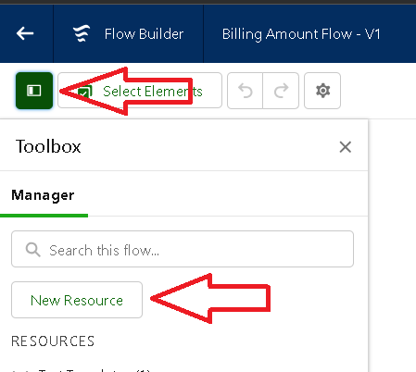

1. Select resource type **Text Template**.
2. Enter API name as **alert**.
3. Change view to **Plain Text**.

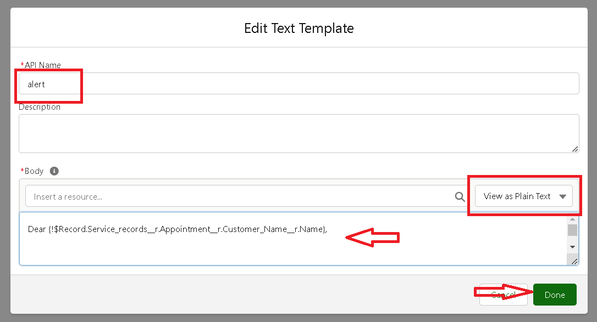

1. Paste the given syntax in the body field.
2. Click on **Add Element (+)** and select **Action**.
3. In the action search bar, type **Send Email** and select it.
4. Give the **Label** as **Email Alert** (API name auto-fills).
5. In **Set Input Values**, enable the **Body** field.
6. For **Body**, select the text template created earlier: **{!alert}**.
7. In **Recipient Address List**, add the email field from the record:  
   **{!$Record.Service_records__r.Appointment__r.Customer_Name__r.Gmail__c}**
8. For **Subject**, type: **Thank You for Your Payment - Garage Management**.
9. Click **Done**.

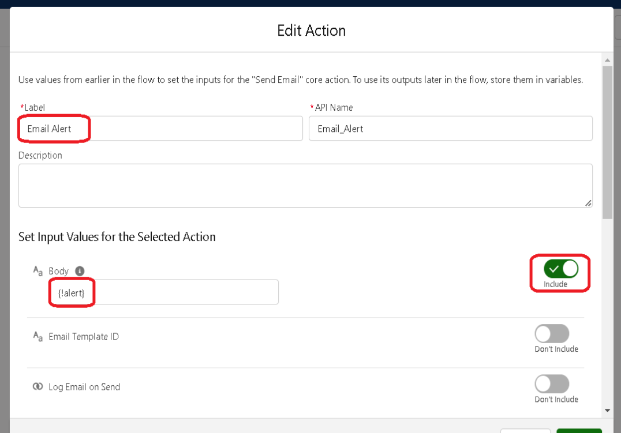

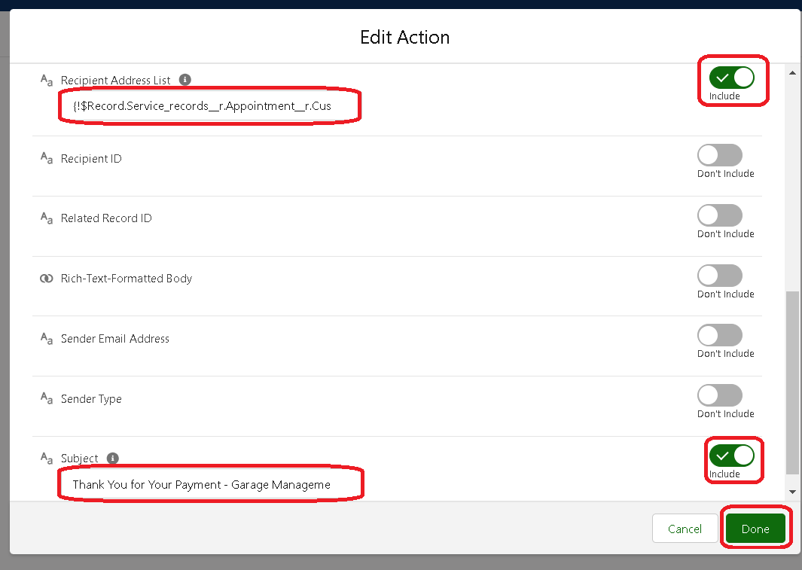

1. Click **Save**, enter a **Flow Label** (API name auto-populates), then click **Save** again.
2. Finally, click **Activate**.

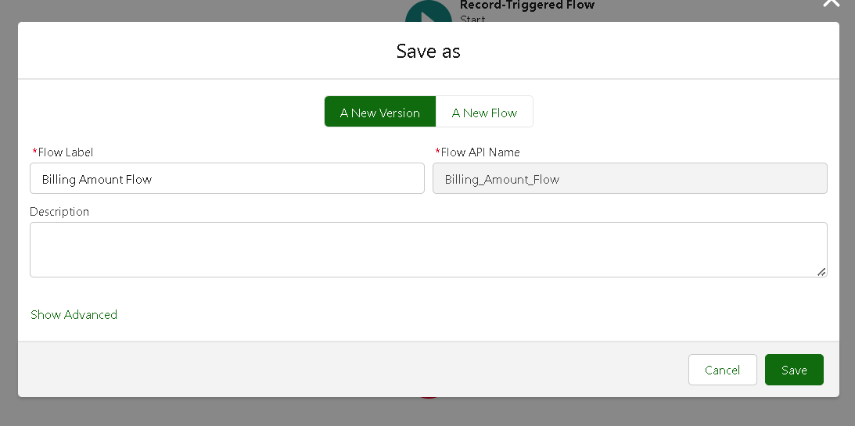

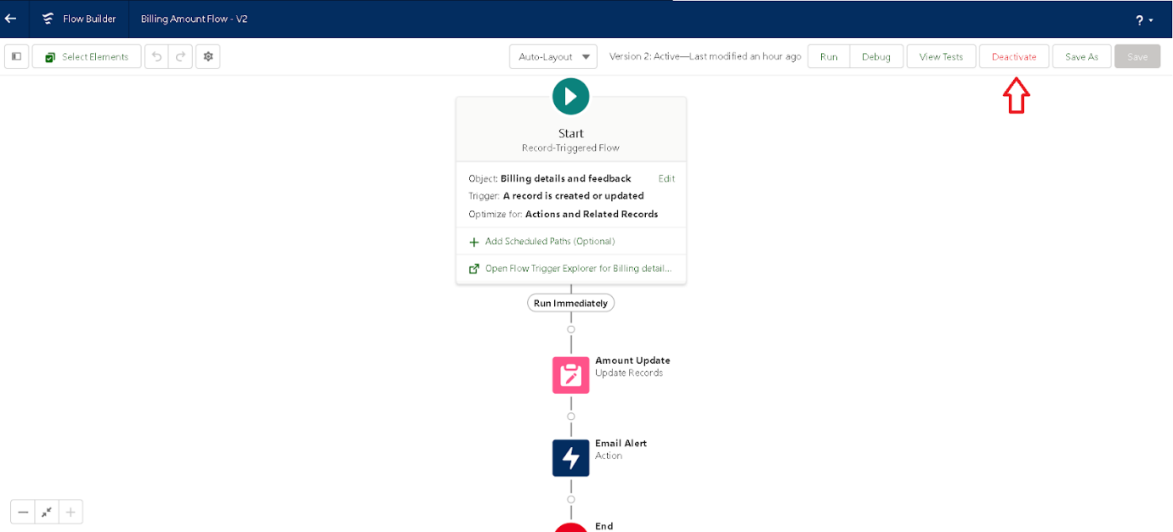

**Create another Flow**

1. Go to **Setup**, type **Flow** in the Quick Find box, and click on **Flows**.



1. Click on **New Flow**.
2. Select **Record-Triggered Flow** and click **Create**.



1. Choose the object **Service records** from the dropdown.
2. Set trigger to **A record is Created or Updated**.
3. Optimize for **Actions and Related Records**, then click **Done**.
4. Click the **+** symbol and select **Update Records**.
5. Set filter condition: **All Conditions Are Met (AND)**
   * Field: **Quality_Check_Status__c**
   * Operator: **Equals**
   * Value: **True**
6. Set field values:
   * Field: **Service_Status__c**
   * Value: **Completed**

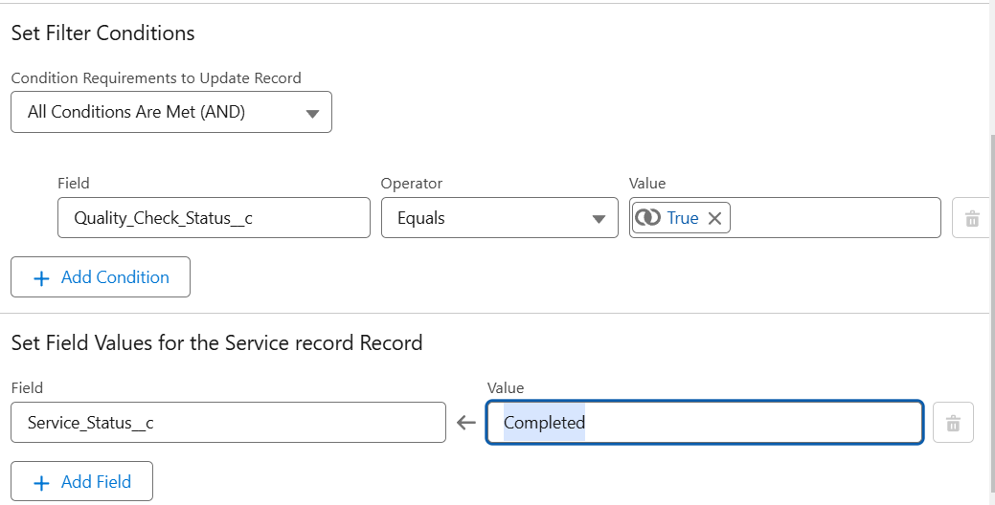

1. Click **Done**.
2. Click **Save**, enter the flow label as **Update Service Status** (API name auto-fills).
3. Click **Save**, then **Activate**.

**Apex handler**

1. **Log in** to your **Trailhead account**.
2. Click the **gear icon** (⚙️) in the top-right corner.
3. Select **Developer Console** — a new window will open.
4. In the Developer Console, click on **File** in the toolbar.
5. Go to **New** → select **Apex Class**.
6. In the pop-up, enter the class name: **AmountDistributionHandler**.
7. Click **OK**.

**Trigger Handler :**

How to create a new trigger :

1. While logged into your **Trailhead account**, click the **gear icon** (⚙️) in the top-right corner.
2. Select **Developer Console** — it will open in a new window.
3. In the Developer Console, go to the **File** menu.
4. Click on **New** → then select **Trigger**.
5. In the pop-up window:
   * **Trigger Name:** AmountDistribution
   * **sObject:** Appointment__c
6. Click **Submit**.

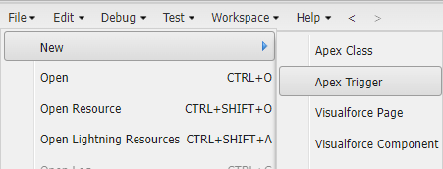

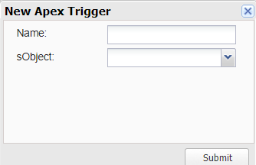

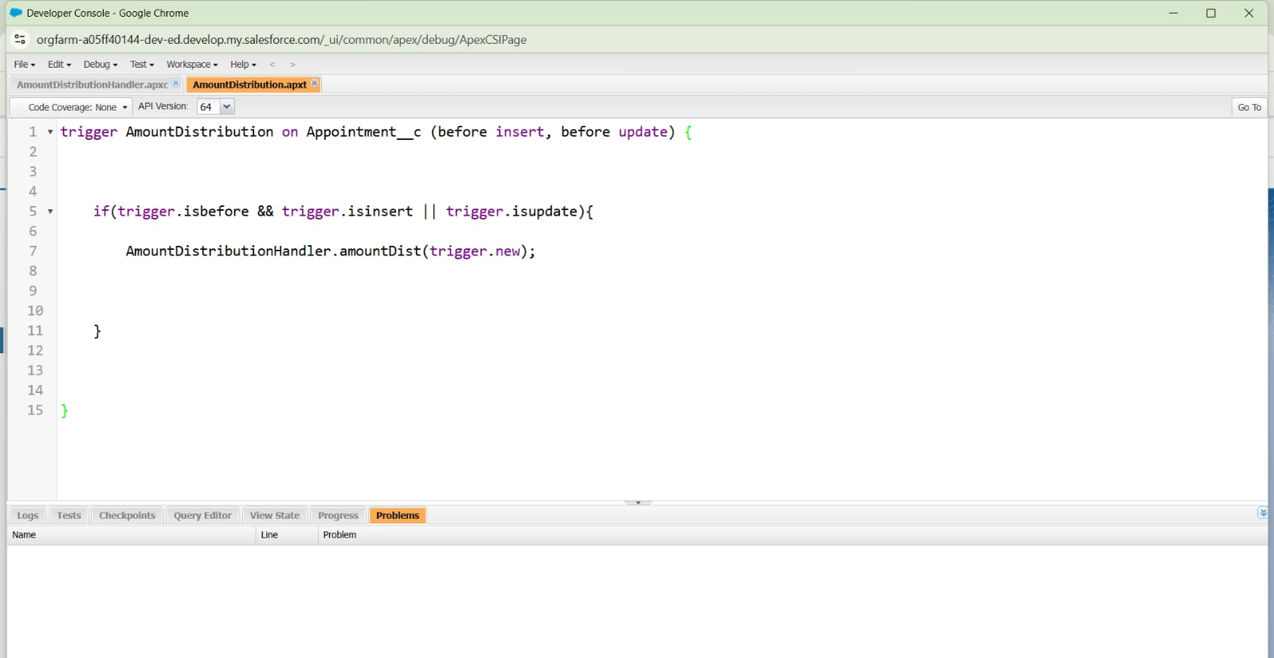

**create a report folder**

1. Click on the **App Launcher** (grid icon) and search for **Reports**.
2. Click on the **Reports** tab.
3. Click on **New Folder**.

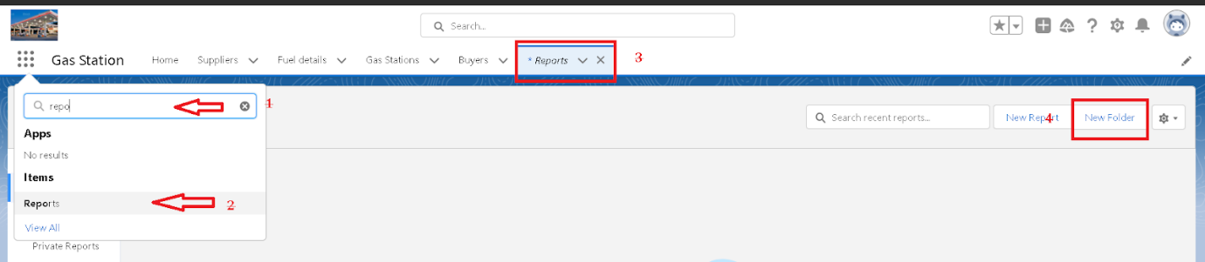

1. Enter the **Folder Label** as **Garage Management Folder** (Unique Name auto-fills).
2. Click **Save**.

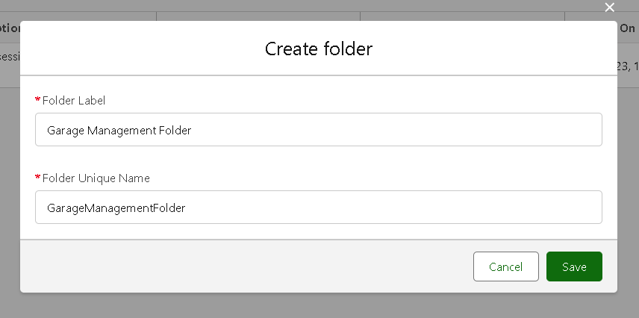

**Sharing a report folder**

1. Go to the **App** and click on the **Reports** tab.
2. Click on **All Folders** on the left side.
3. Find the **Garage Management Folder**, click the **dropdown arrow** next to it.
4. Click on **Share**.
5. In the **Share With** field, select **Roles**.
6. In the **Name** field, search and select **Manager**.
7. Set the access level to **View**.
8. Click **Share**, then click **Done**.

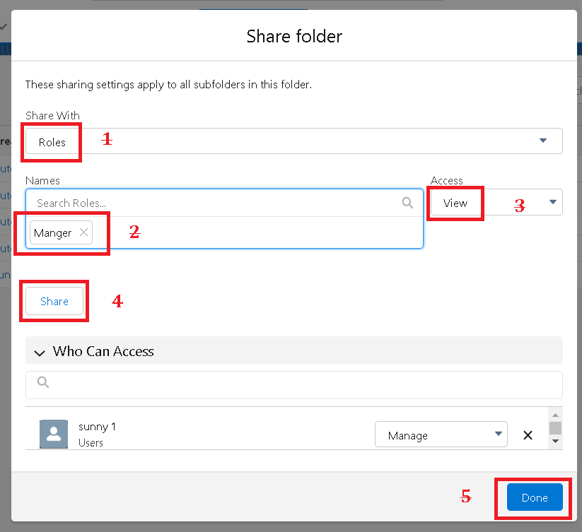

**Create Report Type**

1. Go to **Setup**.
2. In the **Quick Find** box, type **Report Type** and click on **Report Types**.
3. Click **Continue** if prompted.
4. Click **New Custom Report Type**.

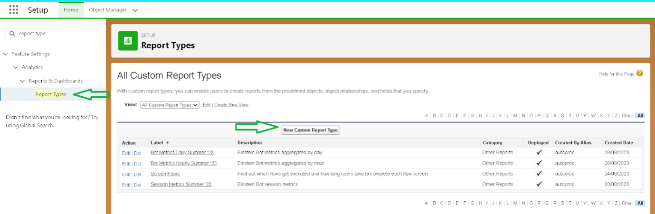

1. Enter the **Report Type Label** as **Service information** (Name auto-fills).
2. Keep the **Description** as it is.
3. Set **Store in Category** to **Other Reports**.
4. Set **Deployment Status** to **Deployed**, then click **Next**.

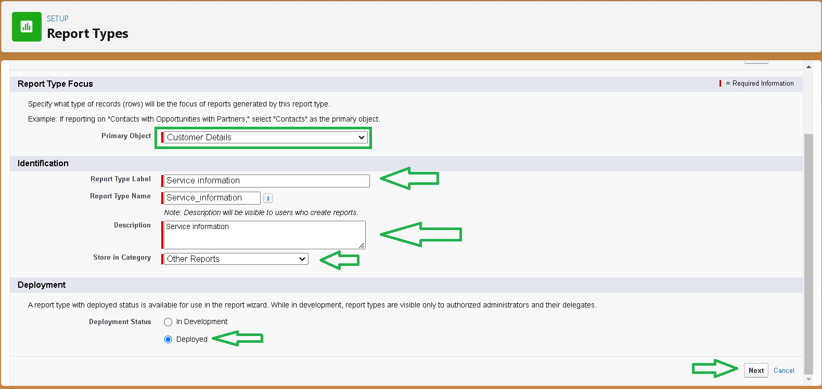

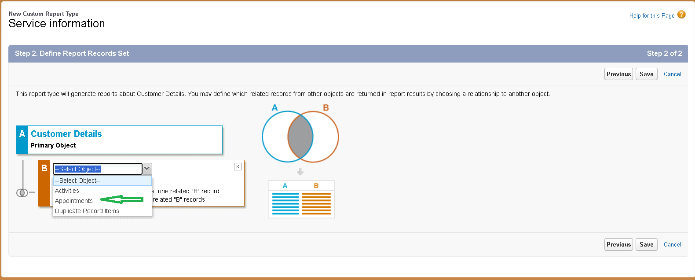

1. Under the **Related Object** box, click **Select Object**.
2. Choose the object **Appointment**.
3. After selecting **Appointment** as the related object, click **+ Click to relate another object**.
4. Choose the related object **Service records**.
5. Again, click **+ Click to relate another object** under Service records.
6. Select the related object **Billing details and feedback**.
7. Click **Save**.

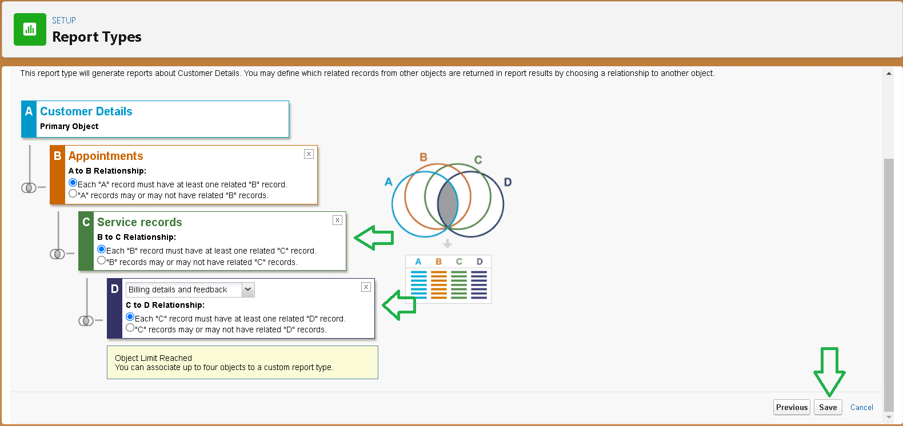

**Create Report**

1. Go to the **App**, then click on the **Reports** tab.
2. Click **New Report**.

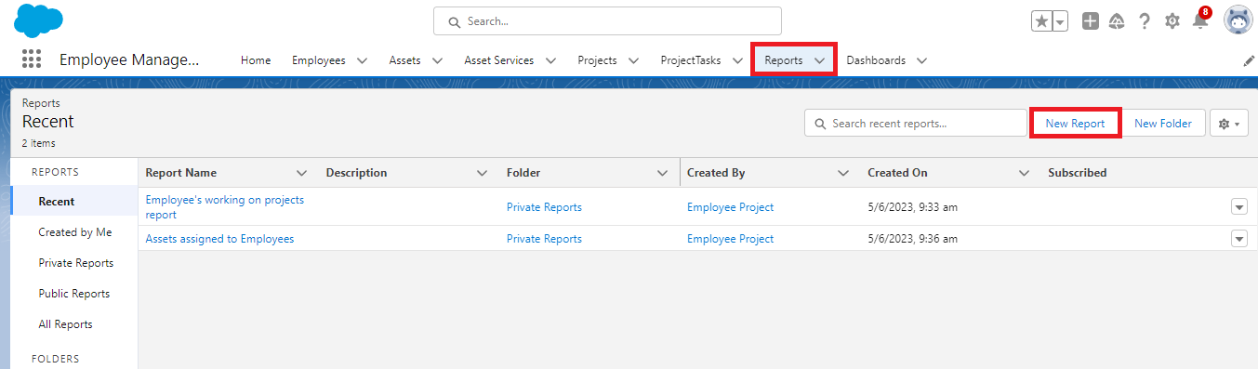

1. In **Category**, select **Other Reports**.

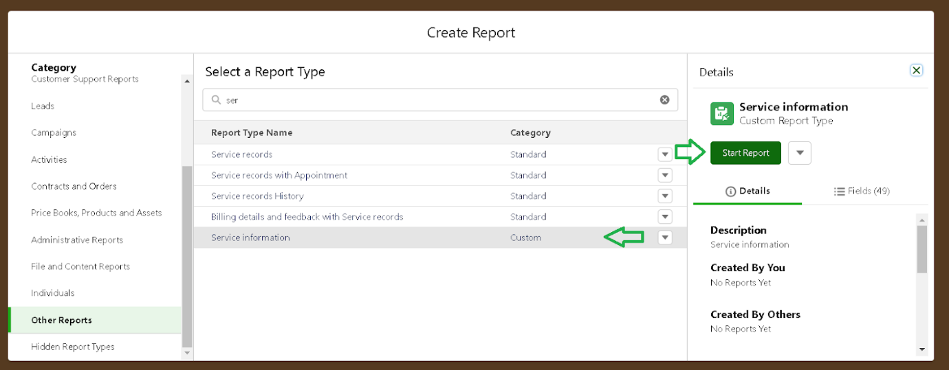

1. Search for **Service Information**, click on it, then click **Start Report**.
2. In the **Outline** pane, under **Columns**, add the following fields:
   * **Customer Name**
   * **Appointment Date**
   * **Service Status**
   * **Payment Paid**
3. Remove any **unnecessary fields**.
4. Under **Group Rows**, add:
   * **Rating for Service**
   * **Payment Status**
5. Click on **Add Chart**, then choose **Line Chart**.
6. Click **Save**.
7. Enter **Report Name** as **New Service information Report** (Unique Name auto-fills).
8. Select the **Garage Management Folder** you created earlier.
9. Click **Save**.

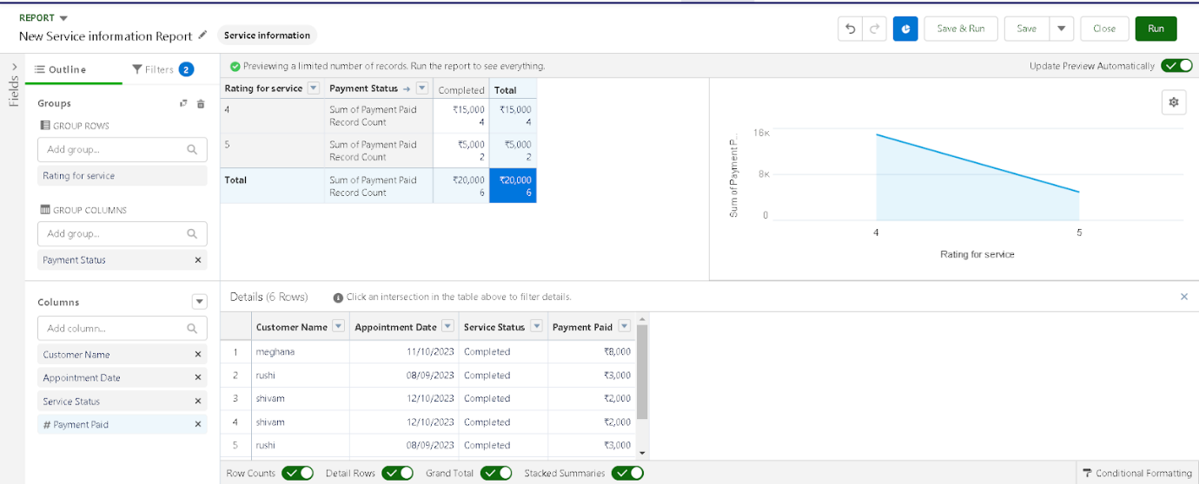

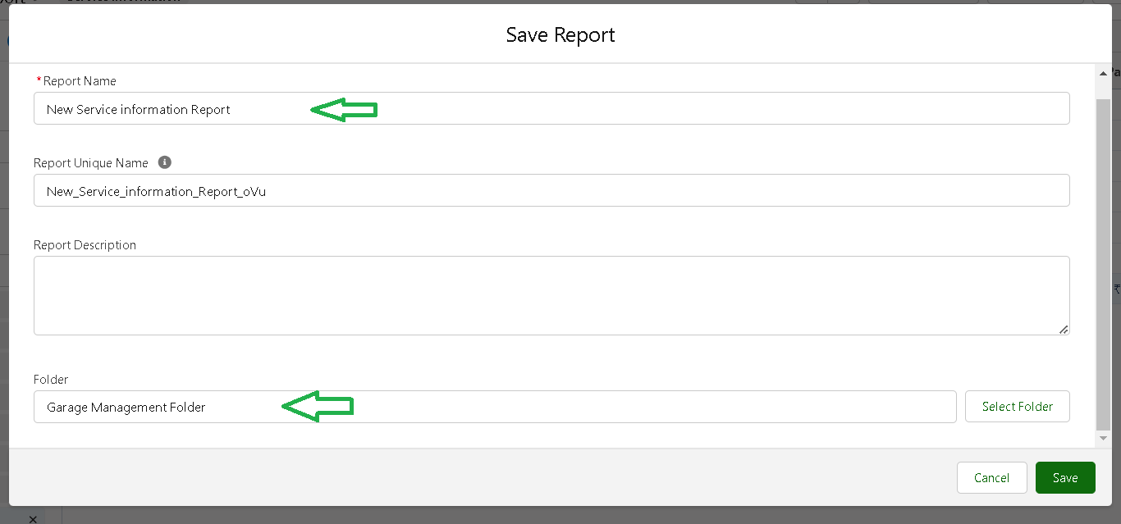

**Create Dashboard Folder**

1. Click on the **App Launcher** and search for **Dashboard**.
2. Click on the **Dashboard** tab.
3. Click **New Folder**.
4. Enter the folder label as **Service Rating dashboard**.
5. Folder unique name will auto-populate.
6. Click **Save**.

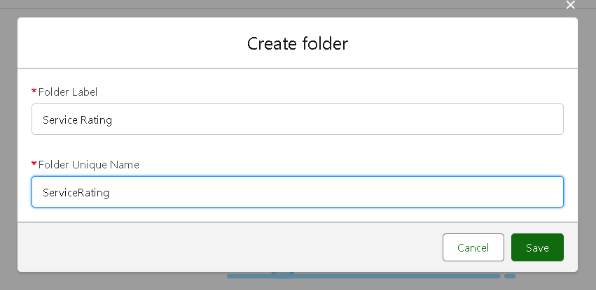

1. Now, follow the same sharing steps you did for the reports folder:
   * Click the dropdown arrow on the new folder.
   * Select **Share**.
   * Share with **Roles**, search for **Manager** role.
   * Give **View** access.
   * Click **Share** and then **Done**.

**Create Dashboard**

1. Go to the app and click on the **Dashboards** tab.
2. Give the dashboard a **Name**.
3. Select the **Service Rating dashboard** folder you created.
4. Click **Create**.

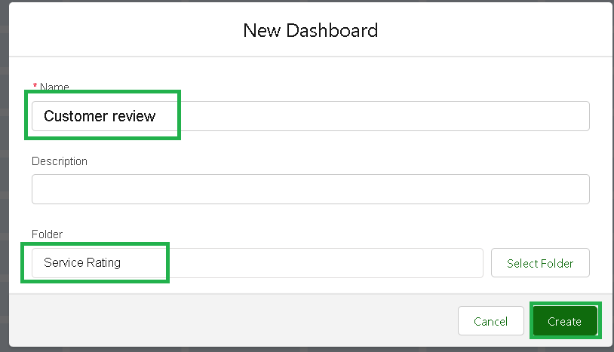

1. Click **Add Component**.



1. Select a **Report** and click **Select**.

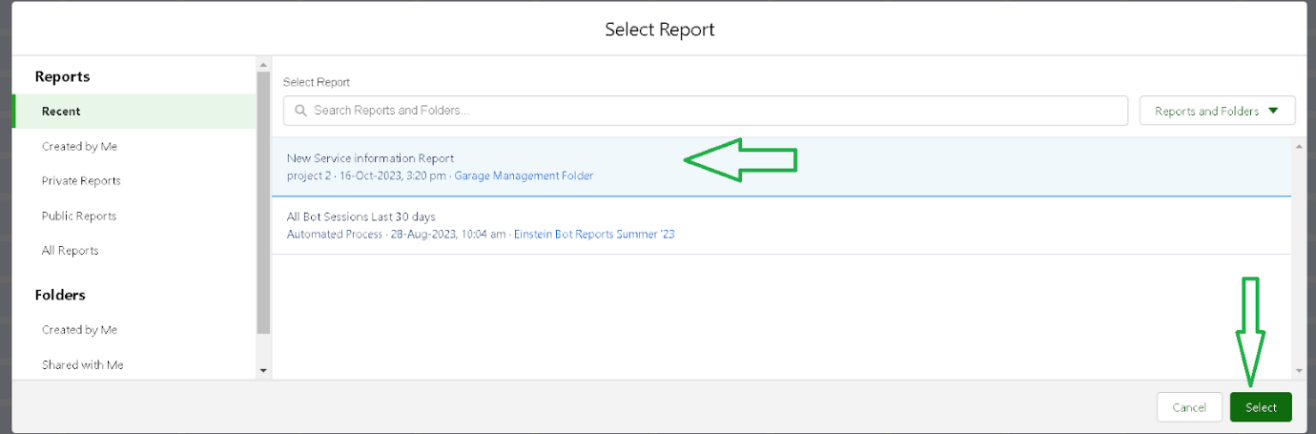

1. Choose the **Line Chart** type.
2. Change the **theme** if needed.
3. Click **Add**, then **Save**, and then **Done**.
4. Preview appears below.

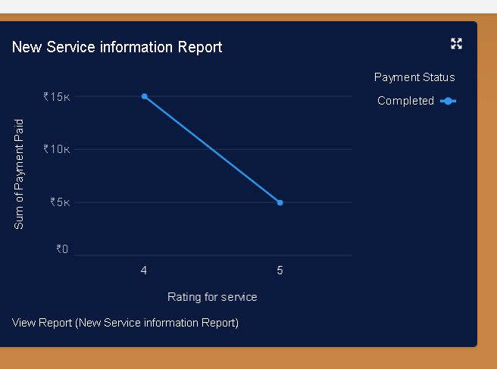

1. Click **Subscribe** on the top right.
2. Set frequency to **Weekly**.
3. Choose the day as **Monday**.
4. Click **Save**.

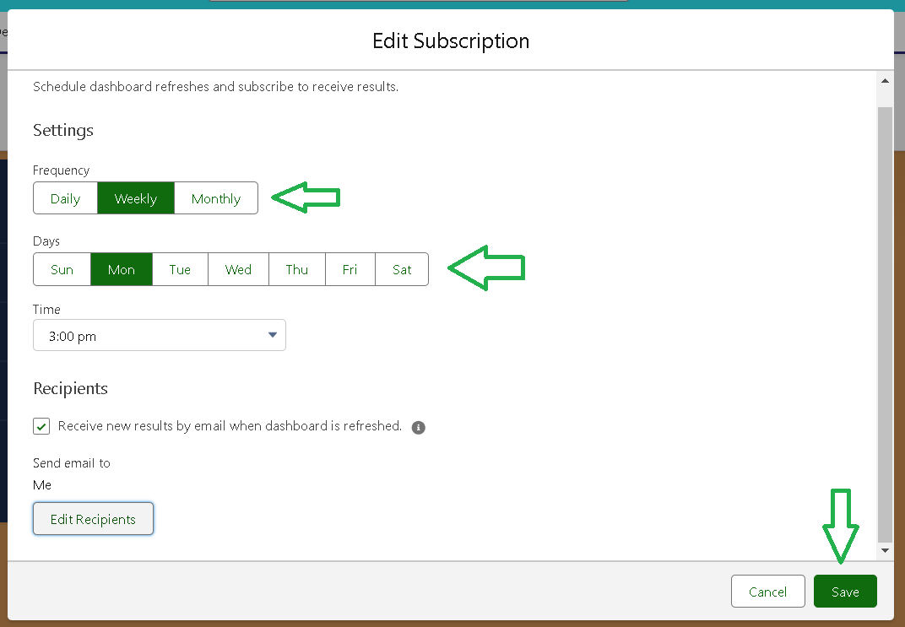

**creating records**

1. Click the **app launcher** (left side).
2. Search and open **Garage Management**.
3. Go to **Customer Details** tab.
4. Click **New**, fill in the details, and click **Save**.

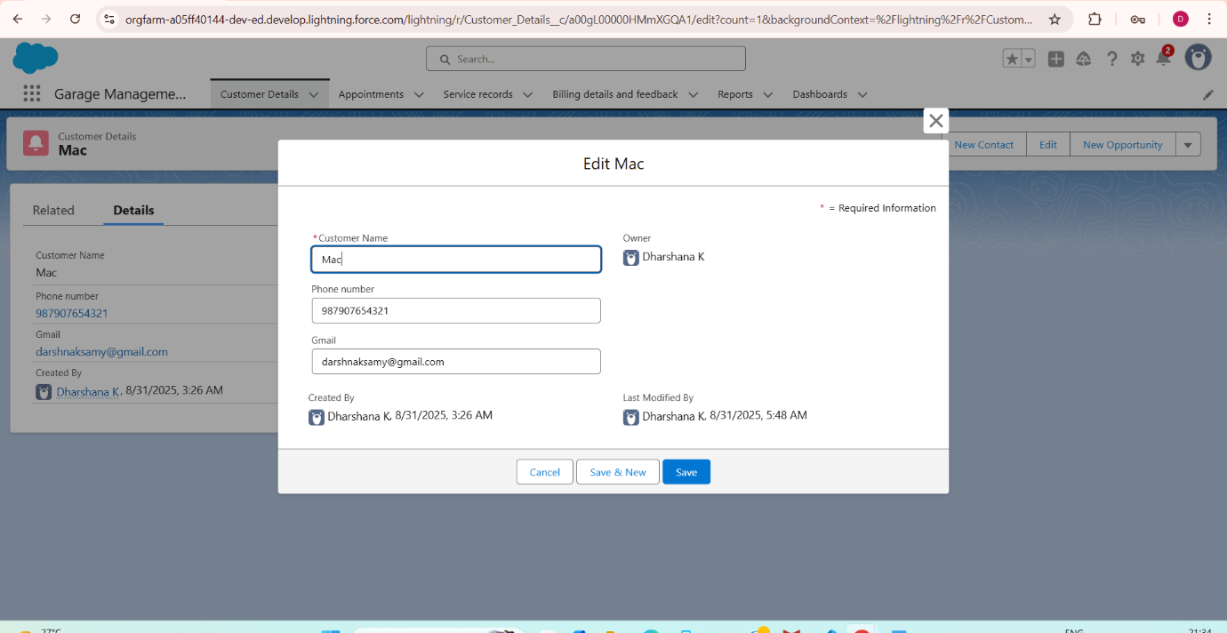

1. Go to **Appointment** tab.
2. Select the created customer, enter an appointment date earlier than today.
3. Enter the vehicle number plate (follow validation).
4. Choose the needed services and click **Save** to see Service Amount.

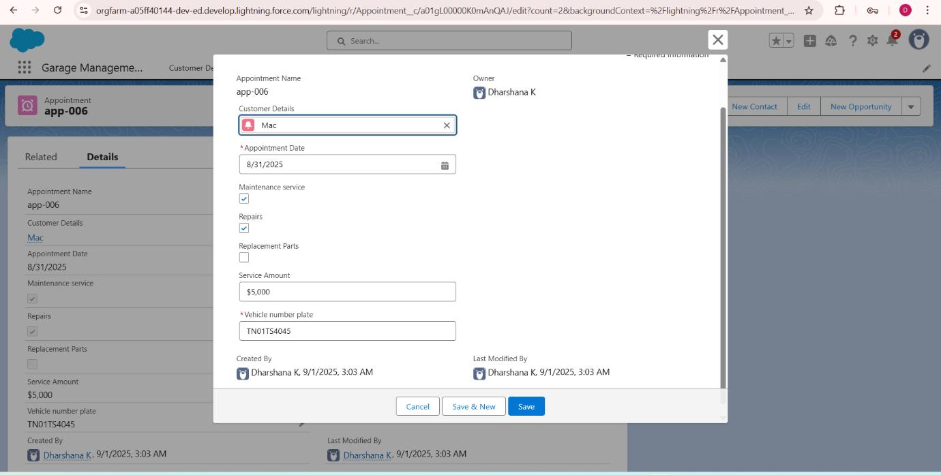

1. Go to **Service Record** tab.

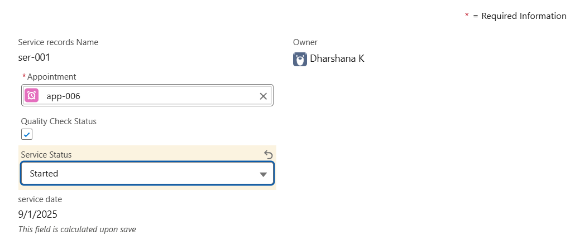

1. Select the appointment, ensure “Started” is selected by default, and click **Save**
2. Open the record, check **Quality Check Status** as true, and click **Save**.

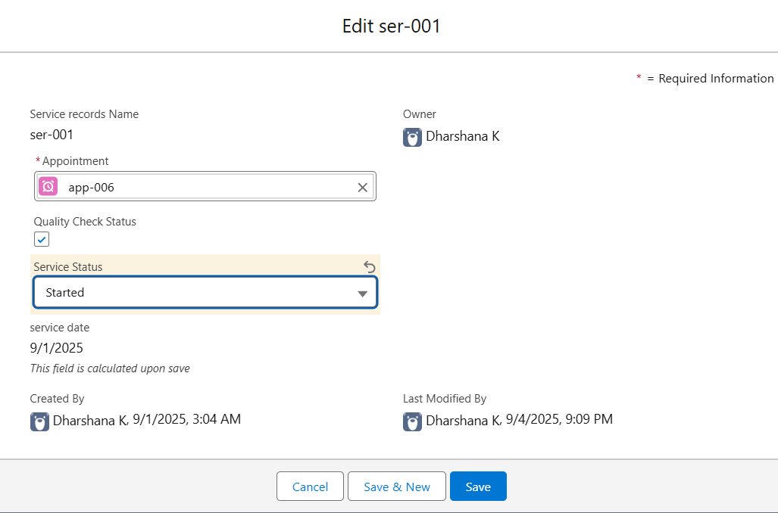

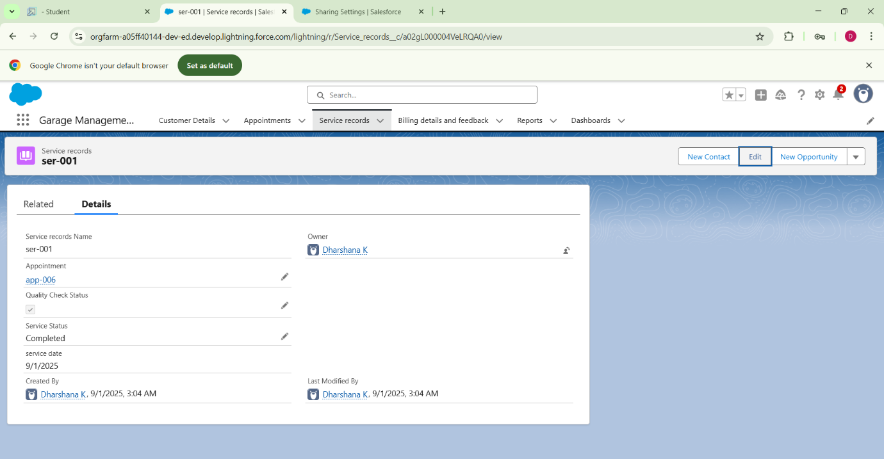

**Conclusion**

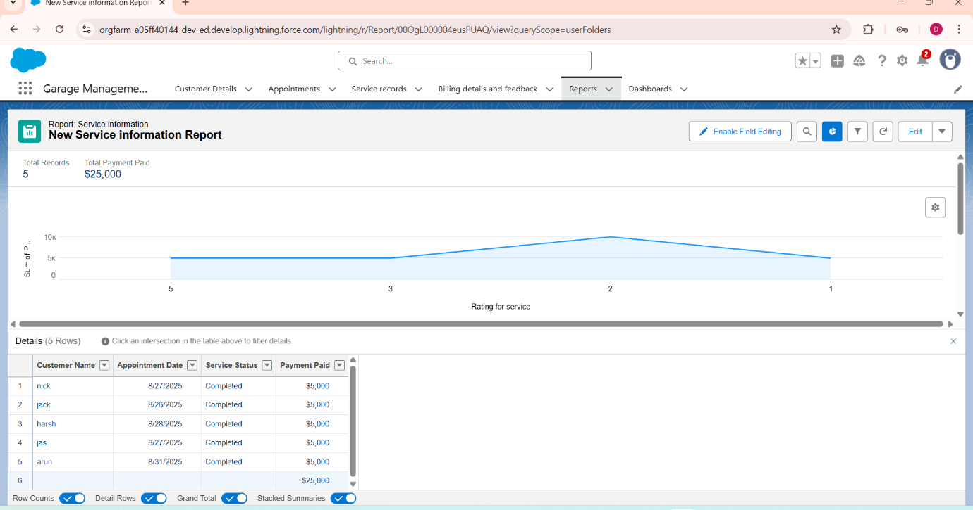

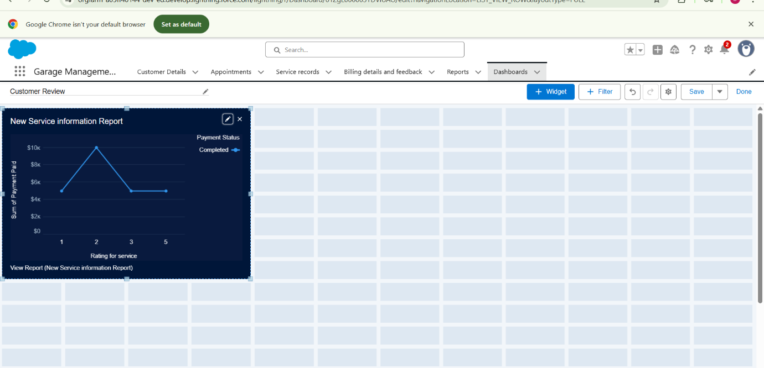

**Our Vision**

* The Garage Management System brings automation to traditional garage processes.
* It improves efficiency in service management and billing.
* Inventory tracking becomes more accurate and reliable.
* Customer satisfaction is enhanced through transparency and timely updates.
* Overall, it ensures smooth operations and long-term sustainability

**THANKYOU!**